



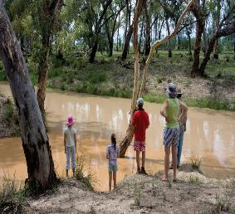Science for a

water-secure future

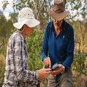Informing sustainable

and evidence-based water security infrastructure

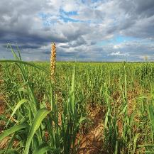

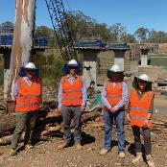

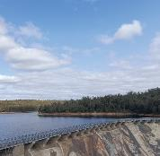

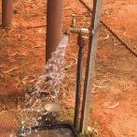

A progress report on the NWGA Science Program

**© Commonwealth of Australia 2023 ISBN 978-0-6456423-2-2**

**March 2023**

**Ownership of intellectual property**

**rights in this publication**

Unless otherwise noted, copyright (and any other intellectual property rights, if any) in this publication

is owned by the Commonwealth of Australia (referred to below as the Commonwealth).

**Disclaimer**

The material contained in this publication is made available on the understanding that the

Commonwealth is not providing professional advice, and that users exercise their own skill and care with respect to its use, and seek independent advice if necessary.

The Commonwealth makes no representations or warranties as to the contents or accuracy of the information contained in this

publication. To the extent permitted by law, the Commonwealth disclaims liability to any person

or organisation in respect of anything done, or omitted to be done, in reliance upon information contained in this publication.

**Creative Commons licence**

With the exception of (a) the Coat of Arms; (b) the Department of Climate Change, Energy, the Environment and Water photos and graphics, copyright in this publication is licensed under a Creative Commons Attribution 4.0 Australia Licence.

Creative Commons Attribution

4.0 Australia Licence is a standard form licence agreement that allows you to copy, communicate and adapt this publication provided that you attribute the work to

the Commonwealth and abide by the other licence terms.

Further information on the licence terms is available from https://creativecommons. org/licenses/by/4.0/.

**This publication should be attributed in the following way:**

© Commonwealth of Australia 2023

**Use of the Coat of Arms**

The Department of the Prime Minister and Cabinet sets the terms under which the Coat of Arms is used. Please refer to the Commonwealth Coat of Arms - Information and

Guidelines publication available at [http://www.pmc.gov.au.](http://www.pmc.gov.au/)

**CONTACT US**

This publication is available in hard copy or PDF format. All other rights are reserved, including in relation to any departmental logos or trade

marks which may exist. For enquiries regarding the licence and any use

of this publication, please contact:

Director, Strategy and Engagement

National Water Grid Authority and

Water Infrastructure Division

Department of Climate Change, Energy, the Environment and Water

GPO Box 3090

Canberra ACT 2601

Australia

**Email:**

[nwga.science@dcceew.gov.au](mailto:nwga.science@dcceew.gov.au)

**Website:** www.nationalwatergrid. gov.au/science



Cover photos: Completing an assessment in the Mitchell Catchment in Qld, by Nathan Dyer, CSIRO Australia. Rookwood Weir construction site visit. Family at the junction of the Teelba Creek and the Moonie River, by Dana Gluzde. Wellington Dam.

Country Water Tap, by Cara Beal, Griffith University.

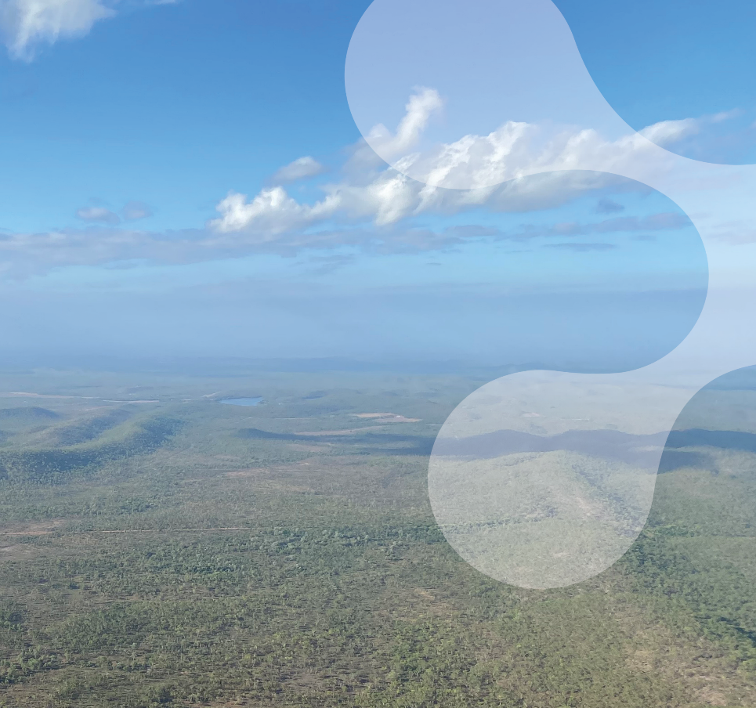

**Acknowledgment of Country**

**The Department proudly**

**acknowledges the Traditional Owners and Custodians of Australia, and their continuing connections to the land, waters and communities. We pay our respects to them and to their Elders past and present.**

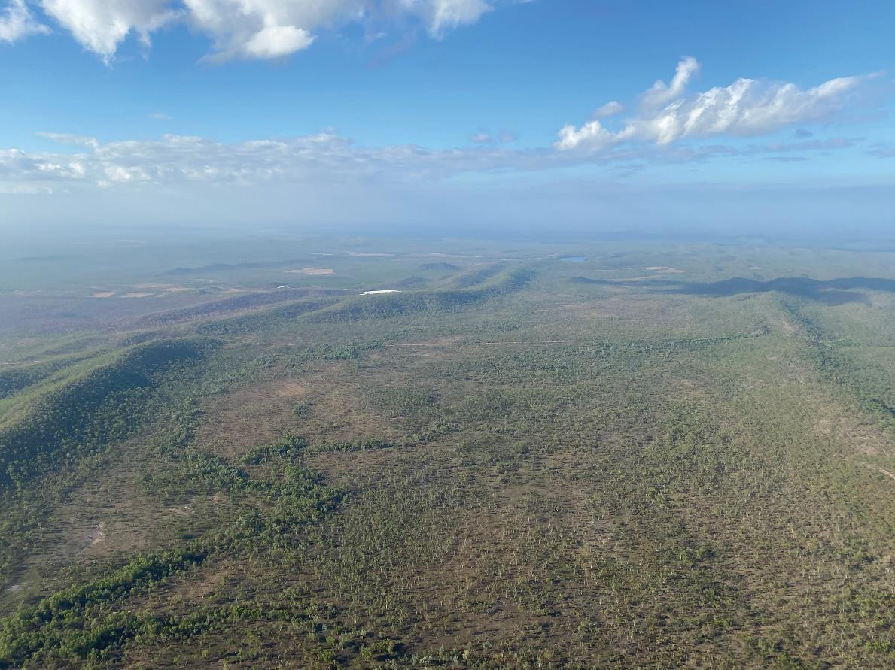

### F O R E W O R D

Living on the driest inhabited continent on

earth, water is one of Australia’s most precious resources. Our decisions on where we build water infrastructure, what we build and how we use it will set us up for a sustainable future.

In many parts of Australia, we’ve just lived through a period of deluge and flooding rains. But meteorologists tell us that La Nina has ended, and that dry years are again on the horizon.

To ensure our water security, and to adapt ourselves to a changing climate, our country needs to invest in effective, efficient, and scientifically sound water infrastructure.

This report details some of these investments. It rests on a simple idea: that every decision made by government should be built on good data and be developed through rigorous science. The National Water Grid Authority’s Science Program is doing just that – building our understanding of water resources and options for their sustainable use across Australia.

Australia is a dry place, but it is also blessed with complex surface and groundwater resources. We need to maximise these resources, through the best available science and government investment. That means improving the

safety and reliability of water supplies in remote First Nations communities. It means using the most climate- resilient water sources, by developing and progressing technologies to use groundwater more effectively and sustainably. And it means implementing circular economy principles in water policy, by increasing the uptake and uses for recycled wastewater.

Our government is committed to improving our understanding of water in Australia, through evolving technology, better data and modelling, and by building the necessary infrastructure. Working collaboratively with state and territory governments

and research organisations, we are working to harness our water supplies in the most environmentally sustainable, responsive, and fair way possible.

As Minister for the Environment and Water, I am excited to see us learn more about our country and grow our scientific knowledge. It gives me confidence that we

The Hon Tanya Plibersek MP, Minister for the Environment and Water.can secure Australia’s water supplies and build a prosperous, resilient, and environmentally sustainable future.



The Hon Tanya Plibersek MP

Minister for the Environment and Water

# Landscape photograph of the Adelaide River Off-Stream Water Storage area in the Northern Territory.Contents

Foreword 2

Summary 5

Introduction: Water is a critical resource

for future prosperity 6

Investing in science for evidence-based

decisions: the NWGA Science Program 10

Taking stock of success:

NWGA Science Program highlights 14

Challenge 1: Understanding water resources – identifying opportunities and risks and

supporting evidence-based planning 16

Opportunity: Water resource assessments

to inform development in northern Australia 16

Opportunity: Understanding groundwater

resources – out of sight but not out of mind 18

Opportunity: Improving data, modelling

and information 20

Challenge 2: Investigating and progressing

alternative water sources and technologies 22

Opportunity: Managed aquifer recharge 22

Opportunity: Increased re-use of wastewater 25

Opportunity: Greater use of brackish

or saline groundwater 26

Conclusion: Looking towards a water-secure future 28

NWGA Science Program project descriptions 30

References 32

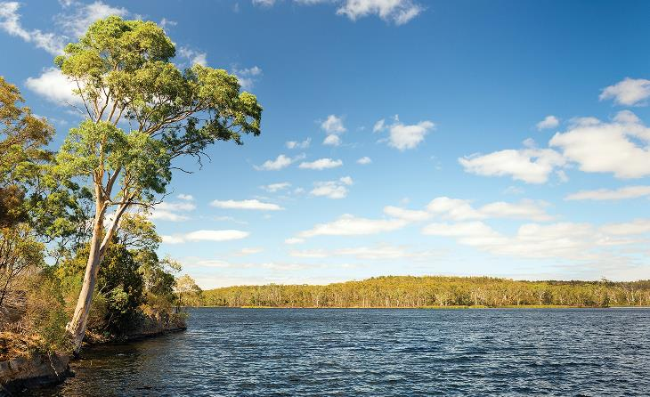

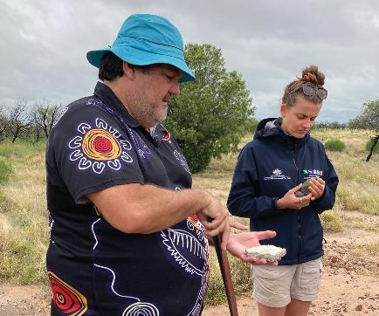 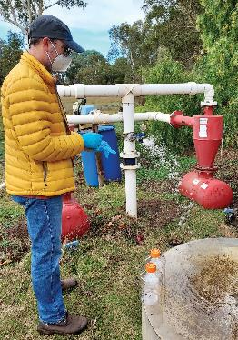

Commonwealth Environmental Water Office Local Engagement Officer Jason Wilson and First Nations Engagement Officer Lani Barnes inspect rocks at Narran Lakes, NSW. Photo: Sonia Wood, Commonwealth Environmental Water Office.

Omics sampling at Lake Breeze winery.

Photo: Karen Barry

# Summary

## The National Water Grid Authority Science Program supports evidence-based water infrastructure investment decisions and solutions to secure water for Australia’s future.

The National Water Grid Authority (NWGA) is the Australian Government’s lead agency for national water infrastructure development. The NWGA works in partnership with state and territory governments to

identify, plan and invest in water infrastructure projects that increase water security, support thriving regions and build resilience to a changing and variable climate.

An increasing population and a drying climate

create pressures on water supplies. This adds to the growing need for sustainable water infrastructure and development of technologies to improve water supply across Australia.

Strong and defensible science is essential to ensure water infrastructure investment decisions are evidence-based and robust. The NWGA Science Program has funded more than 30 research projects totalling $48 million since its commencement in 2019. This suite of work draws on national and international best practice to help identify and progress suitable infrastructure options to support and develop sustainable communities and industry.

Through strong partnerships and a culture of collaboration and science excellence, the NWGA Science Program delivers high-quality practical applied science. Projects increase our knowledge of how much water is available and the impacts of different ways of using water, and help to identify, assess and trial new

opportunities and technologies to improve water supply.

NWGA Science Program research is building knowledge and data to inform sustainable development of water resources and develop climate-resilient options for Australia’s water security. Highlights include:

* Comprehensive water resource assessments to examine the feasibility, economic viability and sustainability of water resource development in northern Australian catchments. These consider how much water is available and how much can be sustainably extracted, as well as environmental, cultural, economic and other community objectives
* An assessment of where managed aquifer recharge could be viable for agricultural or other uses, based on what areas met three key requirements:

ongoing demand for water for high-value agriculture; water available for recharge; and a suitable aquifer for storage

* An appraisal of low-cost desalination opportunities for agriculture that set out requirements, benefits and challenges for successful operations and

mapped areas with potential brackish or saline

groundwater resources

* An analysis that mapped prospective regions, locations or sites for potential re-use of treated wastewater for agriculture
* A detailed review of the Bradfield Scheme that found that diverting water south from northern Queensland was technically feasible but not economically viable. The review found that the water could be better utilised closer to the source, with better economic returns and much less water loss.

In the coming years, the NWGA Science Program will deliver extensive information and data to support water infrastructure investment decisions and solutions. Projects will build on previous research and will:

* progress opportunities to use more climate-resilient water sources and technologies, including managed aquifer recharge, wastewater re-use and brackish groundwater
* include a focus on safe and reliable water for regional and remote communities, in alignment with the new National Water Grid Investment Framework published in October 2022
* continue to analyse water resources and the sustainability of their use, with a focus on groundwater across Australia and both surface and groundwater in Australia’s north
* develop new information tools and resources to support

decision-making.

Secure access to reliable water supply is essential for Australia’s wellbeing and prosperity. It is essential in building resilience to a changing climate.

The NWGA Science Program provides a collaborative and national research portfolio to deliver sound science to secure water for our future.

# Introduction: Water is a critical resource

for future prosperity

## Water is essential to our way of life – to Australia’s unique ecosystems, communities and economy. Today’s decisions on water infrastructure and water resource development, based on sound science, can help build a water-secure and sustainable future.

Water is essential. It supports life and its cultural and spiritual values are vital for First Nations culture and identity. Water drives Australia’s agriculture and primary industries, supporting more than 220,000 jobs and injecting billions into our national economy each year1. Water is fundamental for our national identity, our way of life and our economic prosperity.

Decisions we make today on how and where we develop water resources, and how we develop and use new technologies, can have a profound effect on Australia’s future. A robust evidence base will help us make sound

water infrastructure investment decisions to improve water security, generate public benefit, respond to climate change, and build and use water infrastructure in a way that is environmentally sustainable and culturally responsive. The NWGA Science Program was established in 2019 to provide this scientific evidence base.

This report provides a summary of the NWGA Science Program. It includes progress, highlights and opportunities identified through the program.

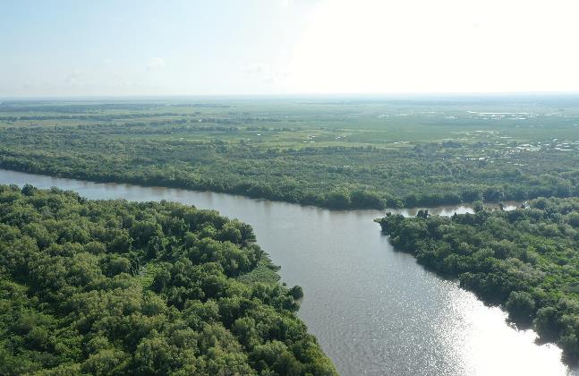

Adelaide River, Northern Territory. Credit: Northern Territory Government

#### Australia’s water in a shifting climate

To manage Australia’s variable rainfall, we rely on capturing and storing surface water for future use, or use groundwater or alternative sources. Continued warming and shifting rainfall patterns will reduce water available for storage, increasing water security risks for communities, industries and the environment.

Australia is the driest inhabited continent on earth and much of the population lives in areas with highly variable rainfall. Extreme events, such as droughts, floods and bushfires, also affect Australia’s water resources.

To manage swings between wet and dry years, communities and regional industries rely on stored surface water and groundwater reserves. Australia has over 500 major water storages (a major storage has a total storage capacity of 1 gigalitre (GL) or more), several thousand small storages and more than two million farm dams. Most mainland storages are in the south- east, supporting irrigation areas and major cities.

Australia’s climate is changing. Rainfall is highly variable across the country, with a shift towards drier conditions across the south-west and south-east of Australia since the 1970s and 1990s, respectively. Years of below-average rainfall have become more frequent, especially for the cool season months of April to October (Figure 1).

The 2017–19 drought was wide-spread and unprecedented in some regions, particularly in the northern Murray–Darling Basin. By contrast, northern Australia was wetter across all seasons in these years, especially in the north-west during the wet season (October to April).2

Climate projections from the Bureau of Meteorology and CSIRO indicate that Australia will likely experience continued warming in the coming decades, with

more very hot days and increased evaporation. Cool season rainfall across much of the south and east is expected to decrease further, leading to more time in drought.3 Drought creates significant water security challenges for agriculture, regional communities and our unique ecosystems.

###### GROUNDWATER is water naturally occurring beneath the Earth’s surface in rock and soil pore spaces and in rock fractures.

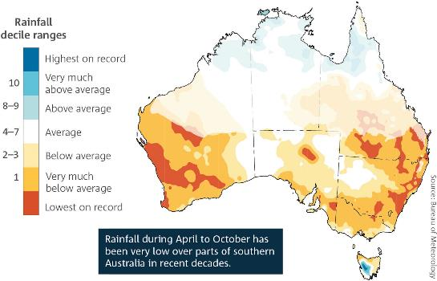

Figure 1: Australia rainfall trends, 2000-2021. April to October rainfall deciles showing where rainfall is above average (aqua and blue colours), average (white) or below average (yellow and red colours), compared with the entire rainfall record from 1900. Source: Bureau of Meteorology

#### Alternative water sources to meet demand

Drying conditions and a growing population increase our reliance on alternative water sources such as desalinated water. Alternative water sources are

an important part of Australia’s water future.

Drying conditions across much of the country have contributed to below-average streamflow. Alongside the continued warming, Australia’s population is increasing4, placing further pressure on finite water resources.

Less of Australia’s water needs are being met using surface water, such as streams, rivers, lakes and reservoirs, and more by groundwater and alternative water

sources.5 Groundwater now makes up approximately 17% of accessible water in Australia6 and in 2019–20 accounted for 20%7 of our total water sourced for use.

For many capital cities, state and territory governments have introduced seawater desalination and water recycling to secure adequate water supply. The use

of desalinated water is expected to continue to increase. In 2019-20, desalinated water made up 4% of the total water supply compared with 1% during the previous year.8 For Perth, desalinated seawater provided 18% of the water sourced in 2019–20.

Exploring new opportunities and technologies to develop and use alternative water sources to increase water security will continue to be an important area of focus in the future.

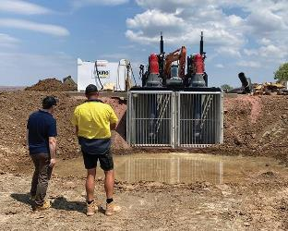

Site visit to Cave Springs Road Tail Water Return System

#### Creating a secure water future: the National Water Grid Fund

In Australia, state and territory governments are responsible for managing, planning, and regulating water resources. The NWGA works in

partnership with state and territory governments to invest in water infrastructure projects to increase water security, adapt to climate change and sustainably develop water resources.

The NWGA manages the National Water Grid Fund (the Fund) which is the Australian Government’s primary infrastructure investment program to improve water access and security. Through the Fund, the Government is investing in water infrastructure projects around Australia, including on-ground construction, business cases and research (Figure 3).

Investment in water infrastructure aligns with the Government’s broader water agenda and the

National Water Initiative – Australia’s national water reform blueprint. This Initiative is a commitment

by all Australian governments to underpin the sustainable management of our water resources.

The National Water Grid Investment Framework outlines the strategic objectives and principles for investment through the Fund and was updated in October 2022,

to allow funding for a broader range of projects. The Investment Framework sets out 3 strategic objectives for Government investment through the Fund:

1. Provide safe and reliable water for regional and remote communities
2. Generate public benefit through responsible investment in water infrastructure for productive use
3. Build resilient water infrastructure that is

environmentally sustainable and culturally responsive.

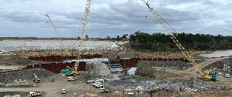

Construction at the Rookwood Weir in the lower Fitzroy River catchment, Queensland

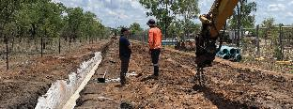

Katherine Connections project

# What is the National Water Grid?

The National Water Grid consists of a series of region-specific water storage and distribution solutions to secure predictable supplies of water now and into the future (Figure 2). It comprises state and territory water systems and assets, including natural water systems (such as rivers, lakes and groundwater) and built infrastructure (such as weirs and pipelines, and desalination and water recycling plants). (As of end December 2022.)

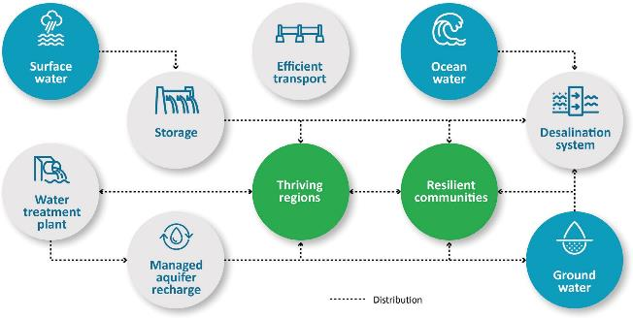

Figure 2: The National Water Grid is a series of state and territory water supply and

distribution systems, including dams, weirs, pipelines and water recycling plants.

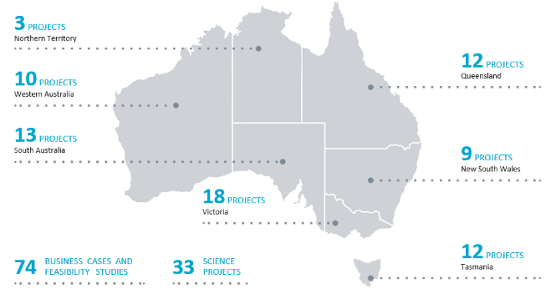Figure 3: National Water Grid Authority water infrastructure projects across Australia. Source: NWGA

# Investing in science for evidence-based decisions: the NWGA Science Program

## The NWGA Science Program funds research to fill knowledge and data gaps, support sustainable water resource development, identify suitable water infrastructure options and progress technologies that can improve water security.

Science plays a vital role in better understanding Australia’s river basins and groundwater resources, informing investment decisions that can increase water security and help achieve social, cultural, economic and environmental benefits.

The NWGA Science Program provides high-quality scientific information and data to inform water infrastructure and investment decisions. A Science Strategy sets out the goals, themes of work and arrangements for guiding Science Program investments. Projects must focus on opportunities, barriers or knowledge gaps relating to where or how water infrastructure could address the strategic objectives set out in the National Water Grid Investment Framework.

The Science Program’s investment in an integrated suite of research projects provides confidence that water infrastructure solutions are fit-for-purpose and tailored to the needs of our regions.

The NWGA Science Program has funded over 30 research projects across Australia, totalling $48 million. At the end of December 2022, 11 projects had been completed and 21 were underway (Figure 4).

The NWGA Science Program:

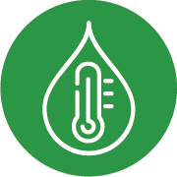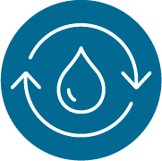

Uses best-practice tools, such as multidisciplinary water resource assessments or hydrological and climate modelling, to understand Australia’s water resources.

This includes understanding

the potential benefits and impacts of using water resources for different purposes.

Identifies and progresses opportunities for alternative and emerging technologies to provide safe and reliable

water supply for communities and regional industries. This includes managed aquifer recharge, desalination of brackish groundwater supplies and water recycling.

Develops and publishes new information resources or communication products to improve access to information and data to inform water infrastructure decisions.

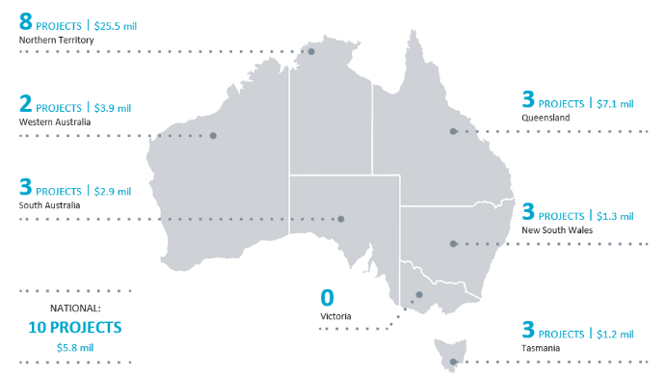

Figure 4. NWGA Science Program projects completed and underway by jurisdiction. Funding figures represent total NWGA funding per jurisdiction.

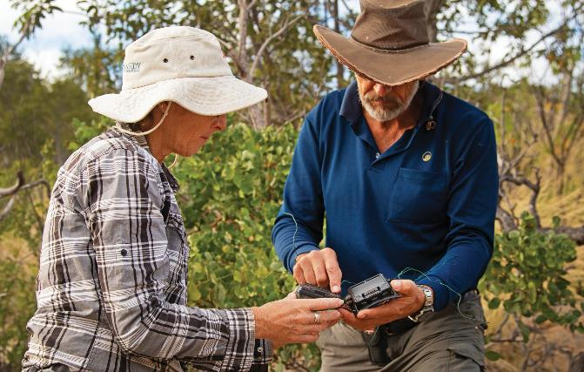

Completing an assessment in the Mitchell Catchment in Queensland. Photo: Nathan Dyer, CSIRO Australia.

#### A partnership approach: collaboration

**for science excellence**

Strong partnerships and a culture of collaboration are core to the success of the NWGA Science Program.

Scientific excellence involves strong collaboration. The NWGA Science Program establishes partnerships and genuine collaboration across relevant Australian Government and state and territory government agencies and research organisations.

State and territory governments are key partners in the delivery of water infrastructure. The NWGA

engages with each state and territory government to consider the science required to inform or progress water infrastructure priorities in their jurisdiction.

Projects complement and enhance national and regional objectives, including in key water catchments such as the Murray–Darling Basin, and support a consistent and strategic approach to Australian Government investment in water infrastructure.

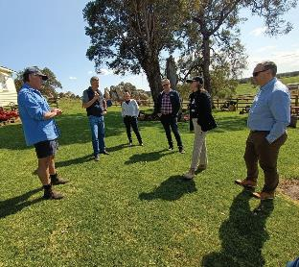

Michael Partridge (right) from the working dairy and veal property White

Rocks discusses water needs with staff from DPIRD and NWGA.

#### Delivering the NWGA Science Program: research and policy professionals

The NWGA Science Program represents a comprehensive portfolio of research projects delivered by world-leading researchers, technical experts and policy professionals.

The Science Program works closely with leading national science institutions, including CSIRO, the Bureau of Meteorology, Geoscience Australia and Australian universities, as well

as with state and territory governments.

NWGA Science Program partners build on the latest Australian and international research to undertake projects that support responsible investment in Australia’s next generation of water infrastructure.

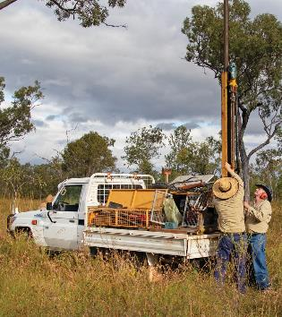

Completing an assessment in the Mitchell Catchment in Queensland. Photo: Nathan Dyer, © Copyright CSIRO Australia

#### Water resources to unlock the

**potential of northern Australia**

There are opportunities to further develop northern Australia. Water infrastructure is needed to meet the demands of new water users, and development must consider environmental sustainability and social and cultural impacts of water use.

Rainfall in much of northern Australia is highly seasonal, with monsoonal rainfall in the wet season and high evaporation rates in the dry season. The region is less developed, with a smaller population and less industry than southern Australia.

The Australian Government has committed to developing Australia’s northern regions, working collaboratively

with local and state governments, business groups,

community members and First Nations people. Development requires secure water resources to support a growing population and economy.

Responsible water infrastructure decisions require an understanding of water resources, economic potential, environmental and cultural impacts, and community interests and aspirations. The NWGA Science Program supports research to underpin evidence-based water infrastructure investment decisions in northern Australia.

Examples include:

* comprehensive water resource assessments in the Roper River, Victoria River and Southern Gulf catchments
* an investigation into whether managed aquifer recharge on the Upper King River could provide greater water security for the Katherine region of the Northern Territory
* several projects aimed at improving modelling and data to underpin water resource allocation and management decisions.

#### Ensuring environmental sustainability

Sustainable management of Australia’s water resources supports industries, communities and the economy. It is vital for maintaining healthy rivers, creeks and wetlands and their unique ecosystems.

Rivers, creeks, lakes, streams and wetlands shape Australia’s landscape. They provide sanctuaries and food for threatened species and other living creatures. They recharge groundwater, filter water and enrich adjacent soils, increasing agricultural productivity.

The NWGA recognises the need to consider environmental sustainability and whether projects are nature-positive when making decisions to invest in water infrastructure.

The Science Program provides information on the potential ecological benefits and risks of water resource development and technologies to increase water security. Projects also support responsible water management by providing an evidence base for state and territory water planning related to new infrastructure development.

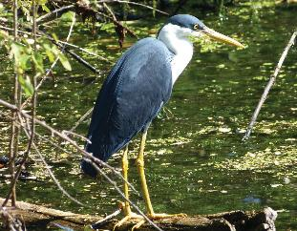

A Pied Heron at Marlgu Billabong on the Ord River

Floodplain. Photo: Jim Mollison

# Taking stock of success:

NWGA Science Program highlights

## The NWGA Science Program delivers a research portfolio to inform sustainable and cost-effective water infrastructure investment and development decisions.

NWGA Science Program research uses applied science to enhance water security. Science Program projects:

Identify opportunities and analyse options for water infrastructure development

Consider what approaches justify further investigation

Examine climate change risks to water security

Progress opportunities for climate-resilient water sources, including wastewater reuse and sustainable groundwater use.

#### CSIRO project site in Aldinga in South Australia.Research highlights from completed

**Science Program projects**

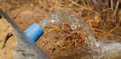CSIRO assessed where managed aquifer recharge could provide increased water security for agriculture. Areas needed to have suitable storage aquifers, sufficient water for recharge and ongoing agricultural demand for groundwater. They identified 6 regions with the potential to store over 50 GL of water. Lachlan, Macquarie and Namoi in NSW; Gingin in WA; Bundaberg in Queensland; and south-east South Australia. CSIRO MAR clogging project field site, Aldinga, South Australia. Photo: Declan Page

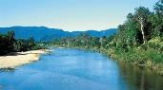Researchers from the National Centre for Groundwater Research and Training at Flinders University used a desktop modelling approach to study how using groundwater to irrigate crops could affect groundwater quality in the Western Davenport region of the Northern Territory. This has led to the Western Davenport Hydrostratigraphy project, which continues scientific investigations to support evidence-based water planning for the region.

A CSIRO review of the feasibility of the Bradfield Scheme (in which water is diverted south and/or inland from the coastal catchments of north

Nine layers of geospatial maps on top of each other.Queensland) found that moving water long distances was technically feasible but economically unviable, with large water losses along the way. The water could be used in northern Queensland, closer to its source, for greater economic return with less water loss and fewer risks. Herbert River, Queensland. Willem van Aken, CSIRO

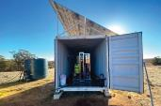GHD applied a geospatial technique to map areas potentially suitable for re-use of wastewater for agriculture. They used more than 20 national data layers relating to factors like soils, available wastewater volumes and locations, identified the relative importance of each data layer and overlaid them to create the final map. Areas to investigate further were found near Sydney, Wollongong, Melbourne, Adelaide, Perth, Canberra and Darwin, as well as in the Pilbara using mining wastewater. Photo: GHD

CSIRO analysed and mapped areas with greater potential for desalination to support agriculture. Key requirements for suitability include feedwater

quality, brine disposal options and energy sources. The identified opportunities and challenges are being progressed through the Brackish Groundwater Characterisation project, with Western Australia as a case study.

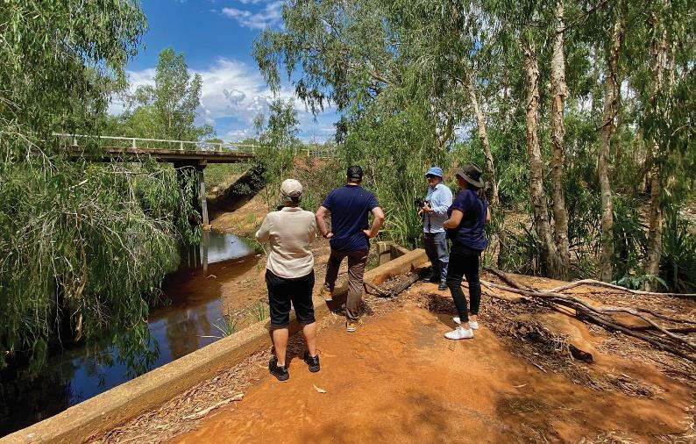

Visiting the Upper King River where the NWGA Science Program is funding a project to investigate managed aquifer recharge to improve water security in the Katherine Region.

#### Meeting Australia’s water

**resource challenges**

Science can provide new information for water planning, help develop technologies such as cost-effective groundwater desalination, and generate options for the provision of water

to regional and remote communities.

NWGA Science Program research projects address key water challenges for Australia. The Science Program is progressing opportunities to address the following key challenges:

* **Challenge 1:** Understanding water resources – identifying opportunities and risks and supporting evidence-based planning
  + Opportunity: Water resource assessments to

inform development in northern Australia

* + Opportunity: Understanding groundwater resources – out of sight but not out of mind
  + Opportunity: Improving data, modelling and information.
* **Challenge 2:** Investigating and progressing alternative water sources and technologies to increase resilience and water security
  + Opportunity: Managed aquifer recharge
  + Opportunity: Increased re-use of wastewater
  + Opportunity: Greater use of brackish

or saline groundwater.

These challenges, and the projects that demonstrate how the Science Program is addressing them, are outlined below.

A complete list of NWGA Science Program projects

is provided at the end of the report (Table 1).

# **Challenge 1:** Understanding water resources – identifying opportunities and risks and supporting evidence-based planning

## Water resource analysis projects provide insights into the feasibility, sustainability and economic viability of water infrastructure options in a catchment or region.

Australia is a vast country with complex systems of surface and groundwater resources. To make sound decisions about suitable water infrastructure for a catchment

or region, water managers need to understand factors

including:

* the location, quantity and quality of water resources
* groundwater flows and recharge rates
* likely impacts of climate change on a water resource
* community interests and aspirations
* the social, cultural, economic and environmental impacts and risks associated with using a water resource.

Water resource analysis can include measuring and collecting data on the quantity and quality of surface and groundwater, topography, geology and soils, climate, and other physical characteristics. Projects can identify and evaluate water capture and storage options, consider potential environmental, social and economic impacts and risks, assess the commercial viability of agricultural and other opportunities

and inform evidence-based water planning.

Water resource analysis projects address questions such as:

* How much water is available, now and in the future?
* How suitable is the water for different purposes?
* How much water can be used from a particular source without negative impacts on the water source, the environment or other water users?
* What are the cultural, environmental, economic and community needs and aspirations relating to the water resource?

In some parts of Australia, particularly in the north, scientific water resource knowledge is limited.

Projects in these areas aim to build foundational datasets and information for water planning and options analyses. In other areas, water resources have been more comprehensively studied. Projects in these areas mainly focus on groundwater resources, which are less well understood.

##### **Opportunity:** Water resource assessments to inform development in northern Australia

Comprehensive water resource assessments provide a foundation for decisions about development options in northern catchments.

The NWGA Science Program funds CSIRO to undertake comprehensive water resource assessments in key northern Australian catchments. These projects evaluate the feasibility, economic viability and sustainability of water and agricultural development.

Water resource assessments recognise the rights of Traditional Owners and aim to identify and support First Nations peoples’ values, rights and development goals.

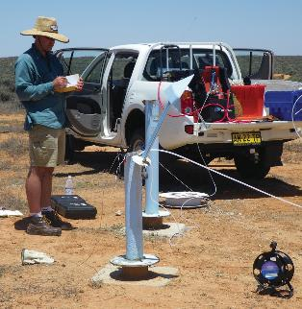

Groundwater sampling. Photo: Geoscience Australia

**RESEARCH SPOTLIGHT:** Assessing

##### northern Australia’s water resources

Water resource assessments provide the underpinning information required to understand the benefits and constraints of water development and infrastructure decisions. This is especially important for considering further development in northern Australia.

Most rivers in northern Australia are unregulated, and current surface water allocations are small. Understanding what and where these resources are, the impacts of extracting water, and the Indigenous rights, values and development aspirations associated with these resources will support decisions on

areas suitable for further development, the types of development that might occur and any associated risks.

Through the NWGA Science Program, CSIRO is conducting water resources assessments in the Victoria River, Roper River and Southern Gulf catchments

of northern Australia. These assessments build on, and use a similar approach to, previous assessments

undertaken in northern Australia through the Australian Government-funded landmark project, the Northern Australia Water Resources Assessment (NAWRA).

These new assessments will fill knowledge and data gaps on soil and water resources across the north of Australia, including on water availability, land suitability, existing uses and impacts of different types and scales of extraction. Water capture and storage options will be identified and evaluated, and the commercial viability of irrigated agriculture and aquaculture opportunities will be assessed.

The research will provide a long-term knowledge base and legacy datasets that will support wise decisions on the feasibility, economic viability and sustainability

#### Accurate information on northern Australia water resources enables water managers to make the right decisions at the right place at the right time.

of water and agricultural development in the study areas. The research will also support broader Australian Government investment and policy decisions on developing northern Australia. The water resource assessments will help all levels of government to explore ways in which water resources can help support further regional economic development.

The assessments will help support state and territory government water planning and the development of updated water resource plans to drive more sustainable water allocation decisions and use in the region.

The findings from this research will support more informed deliberations and discussions on development in the study areas by providing numbers and information that stakeholders can trust. This will

help to focus deliberations and target research and investments on potential development pathways and options that are more likely to be promising.

These northern Australian water resource assessments will ensure sound water-related decisions are made, and will lower the risk of inappropriate development.

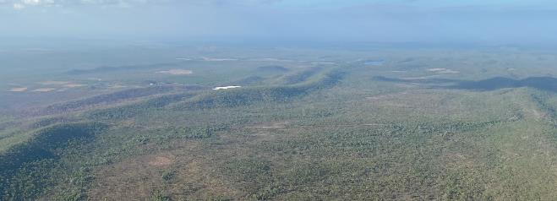

Aerial view of Adelaide River Off-Stream Water Storage (ARWOS), Northern Territory

##### **Opportunity:** Understanding groundwater resources – out of sight but not out of mind

Groundwater is a vital resource in many areas of Australia. Its quality varies, and the impacts of groundwater extraction can take years to become evident. Understanding groundwater quality and movement can identify potential new water supplies and underpin sustainable groundwater use.

Groundwater occurs in aquifers, which are geological formations that can store water. Groundwater supports communities, industries and the environment in urban and rural areas. In many places, particularly where rainfall is infrequent or inadequate, groundwater is the only reliable source for drinking water, agriculture and industry.

In some places, groundwater extraction exceeds replenishment. Some deep groundwater reserves may not replenish at all and drawing water from these sources is akin to mining. In other aquifers, groundwater is replenished when sufficient surface water infiltrates soil and rock.

Groundwater quality varies considerably across the continent. Some groundwater is fresh enough to drink, while elsewhere, it can be brackish or even saltier than the sea.9 Brackish groundwater may be fit for some irrigation or industrial purposes, but not others. New technologies are being developed to reduce the cost and environmental impact of

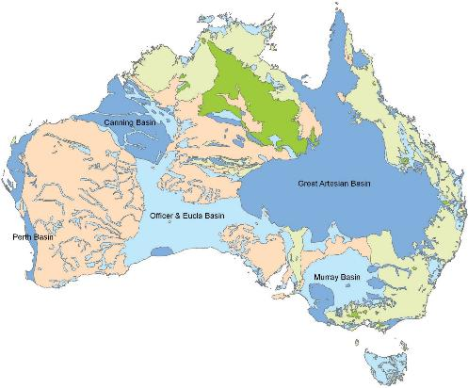groundwater desalination. Understanding and mapping the quality and quantity of groundwater resources

can help decision-makers understand possible

opportunities and costs of using the groundwater.

Groundwater can move through an aquifer, or between adjoining aquifers. When water is taken from an aquifer, typically via a bore, the underground water will move towards the extraction point. This can cause saltier water to move towards the bore, or can reduce the water available to another bore or a groundwater- dependent ecosystem (natural spring) several kilometres away. Groundwater movement can be slow, so impacts may not appear for several years or more.

Understanding this movement is key to sustainable planning and use of our underground water resources.

NWGA Science Program groundwater research includes:

* assessments of the status, location, flow and sustainability of extraction in parts of Tasmania and New South Wales, including parts of the Great Artesian Basin.
* investigating the risk of salinity from irrigation developments in the Northern Territory’s Western Davenport Basin
* exploring opportunities to use brackish groundwater, including options for desalinisation and brine management
* reviewing low-cost options for groundwater desalination for agricultural use.

###### BRINE is water that contains high concentrations of salt. Brine can result from desalination, mining and wastewater treatment.

Figure 5: Hydrogeology of Australia: aquifer

types across Australia.

Source: Geoscience Australia

Porous, extensive highly productive aquifers

Porous, extensive aquifers of low to moderate productivity Fractured or fissured, extensive highly productive aquifers

Fractured or fissured, extensive aquifers of low to moderate productivity Local aquifers, of generally low productivity

**RESEARCH SPOTLIGHT:** Brackish

##### groundwater – is it a viable

water source?

Determining where Australia’s brackish groundwater resources are located and whether they can be desalinated for town drinking supplies, agriculture and industries could provide a new and secure source of fresh water.

Australia has significant undeveloped brackish and saline groundwater. Providing that salt levels can be reduced, brackish and saline groundwater could represent an important water resource on its own or blended with other water sources to support the needs of a region, community or industry.

In areas where freshwater is scarce, desalination of brackish groundwater could increase water security or provide a development opportunity that previously may not have been possible.

Most groundwater studies across the country have examined freshwater resources. As a result, the current estimates of the quantity and chemical composition of Australia’s brackish and saline groundwater resources are uncertain. A more accurate assessment of these resources, coupled with an improved understanding

of advanced brine (rejected saline concentrate) management methods and suitable power supply options and costs, could encourage the deployment of brackish groundwater desalination schemes and help a broad range of stakeholders determine their viability.

Through the NWGA Science Program, CSIRO is exploring, mapping and characterising brackish groundwater resources with an initial focus on Western Australian aquifers. Researchers are examining the chemical composition, groundwater character and behaviour and suitability of brackish groundwater resources and aquifers for development.

The project will explore the feasibility and economic viability of using brackish groundwater, including pre- treatment requirements and available desalinisation technologies. Desalination is energy-intensive, so

the project will also assess opportunities for using renewable energy supplies for the desalination process. Researchers will investigate the water quality suitability required at different locations, including where desalinisation could be optimised for different applications. In such cases, there may be opportunities to better match water quality to the intended water use, and do so with less energy use and lower costs.

As desalination technologies can potentially advance water security and agricultural productivity, this Western Australian project could demonstrate broader utility for this relatively unknown resource and pave the way for a national evaluation of the potential applications of brackish and saline groundwater.

#### Water coming out of a pipe into a pond with brushland in the background.Research into the location and utility of brackish groundwater will underpin decisions on groundwater investment, management and planning by a broad range of stakeholders.

**Opportunity:** Improving data,

##### modelling and information

Water allocation decisions require sound science to balance environmental and cultural needs with water for town supply and economic development. Updating water models and procuring new, high- resolution data improves confidence in water planning and water management decisions.

In many remote areas, there is limited information and data about surface and groundwater resources, their interconnectivity, and the ecology of systems that rely on them. Collecting new data and improving

hydrological modelling can support better water planning in regions with a lack of access to information.

High-quality data is essential for water resource models. Digital and remote methods of collecting data can help to record information about

water resources, topography, vegetation and

infrastructure in remote or hard-to-access areas.

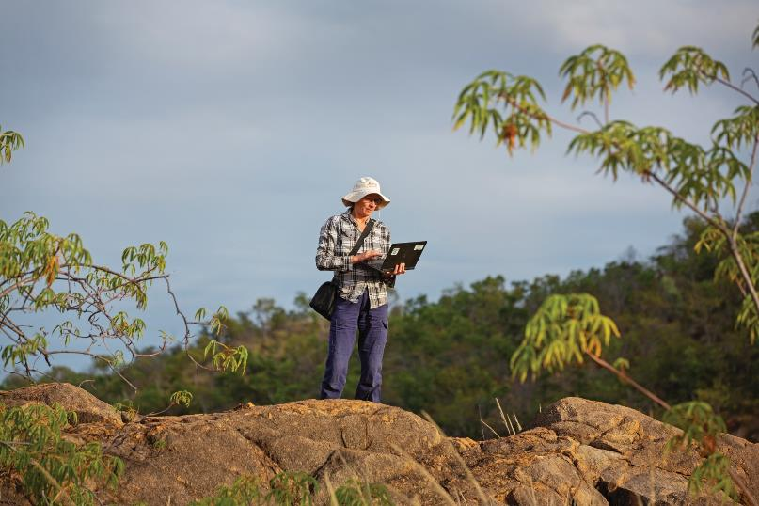Digital elevation models

Completing an assessment in the Mitchell Catchment in Qld

Photo: Nathan Dyer, © Copyright CSIRO Australia

The NWGA Science Program is supporting the Northern Territory Government to collect data to develop high- accuracy digital elevation models and contours over priority surface water extraction areas in the region.

Data will be collected using light detection and ranging (LiDAR), a remote sensing method that generates precise, three-dimensional landscape elevation information. In combination with other data, the elevation mapping will enable accurate determination of the depth to groundwater below the Earth’s surface and will build knowledge of river and floodplain interconnectivity and eco-hydrological function.

This information is central to understanding how much water needs to be retained for the environment and public benefit before water can be allocated

to other consumptive uses. It will help to establish environmental flow thresholds to preserve and maintain ecological and cultural water values within levels of change that are acceptable to communities.

Updated water resource models support water allocation decisions

Resource managers use hydrological and hydrogeological models to simulate surface water and groundwater processes and predict the potential effects of resource development on the

environment and other existing users. With increased knowledge of water systems and the changing climate, these models must be updated to ensure they are accurate and reflect the latest science.

The NWGA Science Program is supporting the Northern Territory Government to recalibrate and refine groundwater models to improve their predictive capability for high-demand water systems in the Territory. The project will enhance certainty on environmentally sustainable yields,

identify water available for allocation, and increase supply assurance to large agricultural projects.

Using climate modelling and hydrology to understand future water availability

Climate models are used to project future conditions such as rainfall, soil moisture and evaporation.

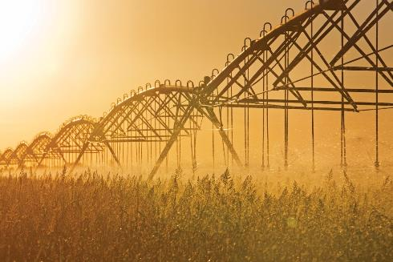Data from climate projections can be combined with water information to better understand how climate change will affect water resources.

**RESEARCH SPOTLIGHT:** Research to

##### support a climate-resilient water future

Climate change affects rainfall, streamflow, runoff and water storage. Understanding how the changing climate is likely to affect Australia’s water resources will support climate-resilient

planning, development and investment decisions.

More time in drought, increased extreme events and changing rainfall patterns will all affect water availability. Rising temperatures and higher rates of evapotranspiration will decrease water availability,

lower soil moisture and slow recharge of groundwater systems. However, a warmer climate is expected to result in more intense rainfall events in some places. These climatic changes present challenges and opportunities for sectors in Australia that rely on water security.

Understanding where increased water stress may occur is critical for preparing and adapting sustainably to future conditions. This information will help

water managers ensure that water resources, the environments that depend on them, and water users themselves, can adapt to the changing climate.

The NWGA Science Program commissioned the Bureau of Meteorology to review the likely impacts on water availability of different climate scenarios for 16 regions across Australia. Researchers combined global climate models with regional scale information on likely future water demand, supply and impacts on agricultural production. This information was

#### A comprehensive assessment of climate change impacts on water resources will provide information on the interaction between multiple climate variables as well as other changes that affect streamflow, water storage and supply

then used to characterise a range of plausible hydroclimatic scenarios and provided insights into how local water availability may be affected.

The NWGA, state and territory and industry decision- makers will use this information to support analysis, planning and investment decisions for a climate-resilient and adaptable secure water future for Australia.

# **Challenge 2:** Investigating and progressing alternative water sources and technologies

## Alternative water sources can increase the resilience of communities, industry or the environment to climate change and rainfall variability. Brackish groundwater, recycled wastewater and managed aquifer recharge have potential to increase water available during times of scarcity.

Water supply can be more secure when an alternative water source is available. Alternative water sources, such as recycled wastewater and desalinated water, are already used in some parts of Australia. These climate-resilient water sources can reduce pressure on drinking water supplies, protect the environment and provide new economic opportunities.

#### Opportunity:

##### Managed aquifer recharge

Managed aquifer recharge is the intentional recharge of water into aquifers for subsequent use or environmental benefit. It can improve water security and provide a drought reserve, as water stored underground won’t evaporate like water stored in surface dams.

Water stored underground is resilient to climate change, as it does not evaporate like surface water. In areas that rely on groundwater, natural recharge may be insufficient to maintain water levels in an aquifer, particularly

when droughts, climate change and population growth put additional pressures on water supply.

###### MANAGED AQUIFER RECHARGE

**involves adding water to aquifers for subsequent recovery and use or environmental benefit.**

In managed aquifer recharge, aquifers are intentionally

recharged. When water is abundant, it can be stored underground until the next drought. This technology, sometimes called water banking, can

increase the security and resilience of water supplies for towns, agriculture or other industries.

Aquifers can be recharged with water infiltrating from the surface via basins or channels, or through active injection via bores.

Aquifers also offer natural water treatment, providing low-cost water quality improvement for alternative water sources such as urban stormwater and recycled wastewater.

Storing water away for a not-so-rainy day

The NWGA Science Program is advancing the understanding and application of managed aquifer recharge across Australia. Projects include:

* a rapid assessment of managed aquifer recharge

opportunities for agriculture

* investigating the feasibility of managed aquifer recharge in the Katherine region
* a managed aquifer recharge pilot in Myalup, WA
* an assessment of NSW hydrological and hydrogeological data to estimate underground storage capacity, location and development opportunities.

Research findings will provide water managers, developers and decision-makers with a better understanding of the applications, opportunities and challenges of managed aquifer recharge and its potential contribution to Australia’s water-secure future.

**RESEARCH SPOTLIGHT:** Developing a pilot managed aquifer recharge scheme in Myalup, WA

A full-scale managed aquifer recharge scheme could assist in securing water supply, improving water quality and expanding food supply markets in the Myalup region in Western Australia. A pilot scheme is needed to test its viability and sustainability.

Myalup is an important agricultural area in Western Australia. It produces a significant proportion of the state’s horticultural produce, with strong export markets.

However, surface water supply and groundwater resources in the region are at risk of decline due to a drying climate, clearing in the catchment and increased water demand. If water resources are not well managed, the region could experience a loss of produce, investment, business and jobs.

The Western Australian Government recognises the benefits of expanding agricultural land and water resources in the Myalup area to enable regional growth. Managed aquifer recharge could assist in expanding the region’s water supply network. Such a scheme could provide greater water storage and supply, resulting in a more climate-resilient and secure water source to support expanded food production for domestic and export markets.

Studies have shown that a managed aquifer recharge scheme may be viable in Myalup, but further exploratory work is needed to determine if it is cost-effective

and sustainable. A pilot scheme to demonstrate proof of concept is the next step towards gaining government and planning approvals for the potential development of a future full-scale scheme.

The NWGA’s Science Program is supporting the WA Department of Primary Industries and Regional Development (DPIRD) to develop a pilot for such a managed aquifer recharge scheme. This Myalup pilot project will pump water from the Harvey River Diversion Drain, which is the closest available water source with sufficient water availability, into 4 basins. This water will infiltrate 10–20 metres through the porous soils of the

DPIRD researcher Dr Richard George, on the site at the Myalup managed aquifer recharge pilot project (currently a cleared area in a mature pine plantation) checking an aquifer monitoring bore.

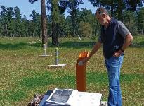

A schematic image showing the operational stages of a managed aquifer recharge scheme.

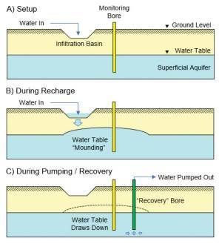

Figure 6. Schematic showing the operational stages

for a managed aquifer recharge scheme. Source DPIRD

basins into the local aquifer. The water would then remain stored in this aquifer to be extracted at a later time, to help determine aquifer response and recovery rates.

As well as demonstrating proof of concept for the storage capability of managed aquifer recharge in the area, the pilot project will examine a range of other factors that must be understood to determine whether managed aquifer recharge in the region

is viable and sustainable in the long term.

The pilot project will investigate the quality of the proposed water source and examine both the behaviour of water once recharged into the aquifer and the potential for the scheme to improve water quality by the recharge process itself. It will also test a range of operational specifics such as optimal storage volumes, timing and

rate of aquifer recharge and methods for water recovery and treatment, whilst ensuring no adverse impacts on surrounding land uses, including forestry, sand mining, irrigated agriculture and local biodiversity. The project will also investigate compliance with regulatory standards and ensure any environmental impacts can be minimised, especially for nearby RAMSAR wetland systems.

Ultimately, the results of this pilot scheme will fill uncertainties and knowledge gaps about managed aquifer recharge. It will inform future investment and infrastructure decisions, including any necessary approvals required before establishing a full-scale managed aquifer recharge scheme in Myalup.

**RESEARCH SPOTLIGHT:** Sustainable managed aquifer recharge schemes



The successful and sustainable operation of managed aquifer recharge schemes will help support a secure water future for Australia. Understanding the causes and prevention of managed aquifer recharge scheme clogging is vital to the long-term success of these schemes.

Managed aquifer recharge schemes can be time consuming and expensive. They involve millions of dollars of investment and infrastructure. To ensure the long- term sustainability of such schemes, various operational factors must be understood so they can be well maintained and offer a return on investment. Clogging

of the recharge infrastructure can significantly limit the volume of water that can be recharged. Clogging can also cause harmful pressure build-up or other damage to the aquifer. In extreme cases, clogging may result in the abandonment of a scheme. As such, clogging represents one of the greatest challenges to the sustainable operation of managed aquifer recharge schemes.



All managed aquifer recharge operations in Australia are hampered, to some degree, by clogging. Addressing this problem requires an understanding of the mechanisms that cause it (including chemical, physical and biological processes), as well as measures that



can prevent clogging and options for overcoming it.

Through the NWGA Science Program, the CSIRO is investigating the causes of, and operational

solutions to, clogging of managed aquifer recharge systems. Through 4 case studies with managed aquifer recharge scheme operators, researchers will analyse the impact of clogging on scheme performance, investigate and test management strategies, and recommend possible solutions.



Project recommendations will help scheme operators, investors and the water industry reduce factors that cause clogging. This will help to ensure the sustainability and viability of managed aquifer recharge schemes.

The findings will apply to all new and existing managed

aquifer recharge schemes across Australia.



#### Managing clogging risks to managed aquifer recharge schemes will build longevity into their operation, adding value to the investment.

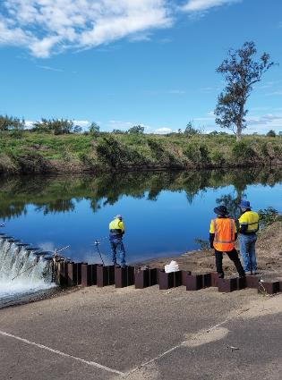



Measuring water quality in a Queensland-managed aquifer recharge

scheme.



**The cost of running out of water is higher than the cost of investing in new alternative water technologies to improve supply resilience, such as**



**wastewater reuse schemes’ Nathan Malcolm, GHD**



**Opportunity:**

##### Increased re-use of wastewater

Wastewater from urban systems has typically been treated and discharged back into river systems for inland catchments, or out to

sea in coastal areas. Re-using this water can provide an additional climate-resilient water resource for communities or businesses.

Treated wastewater from city or town water systems, or other sources like mines, can be re-used. In some parts of Australia, treated wastewater supports agricultural enterprises or maintains green spaces like parks or golf

courses. In Perth, treated wastewater is injected into deep aquifers, to be drawn on in future as part of the city’s water supply.

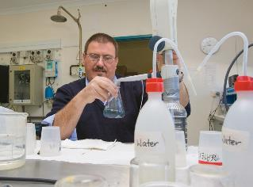

Stromlo water treatment plant. Photo: Dragi Markovic

**RESEARCH SPOTLIGHT:** Reuse of

##### treated wastewater – an emerging alternative water source

Changing climate and population increase put pressure on Australia’s water supply. Use of treated wastewater presents a valuable opportunity to enhance our water resources. Research is required to determine suitable locations for potential schemes to reuse wastewater and to support investment and infrastructure decisions.

Many towns and cities reuse their treated wastewater for agriculture. However, much of Australia’s wastewater is still released into rivers or the ocean, especially from large coastal cities.

Wastewater is largely a climate-independent source of water – it is not reliant on rainfall. Technologies independent of climate will become increasingly important for sustainable water management and could help improve Australia’s water security.

The NWGA Science Program commissioned consultancy

firm GHD to identify opportunities and viable locations for reuse of treated wastewater. The project assessed the benefits, limitations and challenges

of reusing such wastewater for agriculture.

This research identified a number of areas across Australia that could warrant further investigation by jurisdictional governments for the development of new wastewater reuse schemes. These areas were found to be reasonably close to a reliable supply of wastewater, with suitable

soils and support by state and territory legislation.

Areas unsuitable for wastewater reuse are those identified for environmental or cultural heritage conservation; locations with unfavourable land or soil qualities, including areas with heavy tree cover or sandy areas; and regions otherwise unfit for agriculture.

The assessment provides information on the technological, environmental, economic, production and implementation challenges that need to be addressed for expansion

or development of new wastewater reuse schemes. It provides state and territory water planners and regulators with information to underpin deeper site- based analysis and decisions on the use of treated

wastewater. It also helps industries and businesses looking to develop or invest in wastewater reuse schemes.

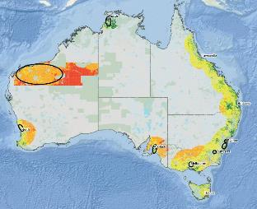

Highly suitable Neutral

Moderately constrained Highly constrained Highly unsuitable Conservation area

Areas of noticeable opportunity

Figure 7: Suitability of locations across Australia for agricultural

wastewater schemes. Source: GHD

**Opportunity:** Greater use of brackish or saline groundwater

Groundwater often has dissolved minerals

or salts that can limit its usefulness. By understanding the water quality requirements for different purposes, and developing low- cost purification methods, we can make greater use of Australia’s groundwater resources.

Mild to moderately brackish (salty) water can be used for some purposes, but the water quality must be carefully matched to its intended use. Another option is to purify the water through a process called desalination. This process removes the dissolved salts, but is energy- intensive and results in highly salty wastewater (brine).

Seawater desalination, where water is purified to drinkable quality, is used in many capital cities to increase the security of water supply. Brackish groundwater can also be desalinated for drinking or other uses. For many agricultural or industrial purposes, the water can be less pure than for drinking or household supply.

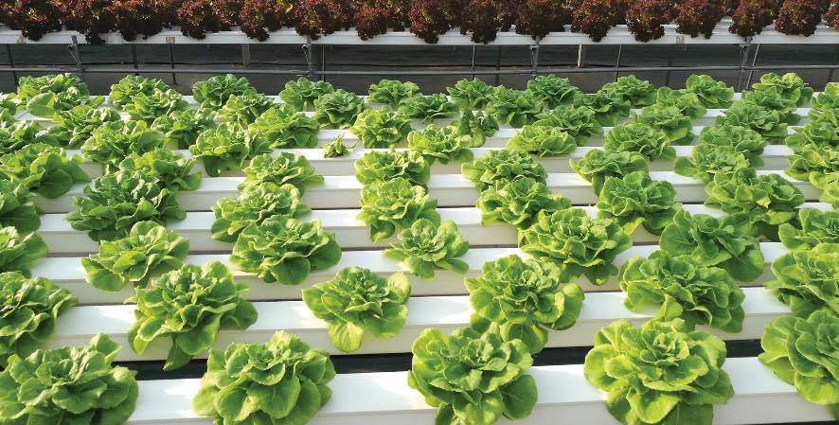Many remote First Nation communities in Australia rely on groundwater resources with high levels of dissolved minerals or heavy metals. Future projects under the updated National Water Grid Investment Framework could investigate groundwater desalinisation technologies suitable for remote community settings.

Desalinated water can be used for high value crops.

Several NWGA Science Program projects aim to address barriers to increasing the use of brackish groundwater. For example, a CSIRO appraisal of low-cost desalination opportunities for agriculture found desalination technology can be most beneficial in areas where:

* groundwater is of moderate salinity
* groundwater is stored in highly transmissive and thick aquifers
* agriculture is close to the coast for disposal of brine
* the desalinated water is used to irrigate high-value crops.

Other projects consider how brackish groundwater resources can be matched to agricultural uses in parts of South Australia and investigate methods for cost-effective brine management.

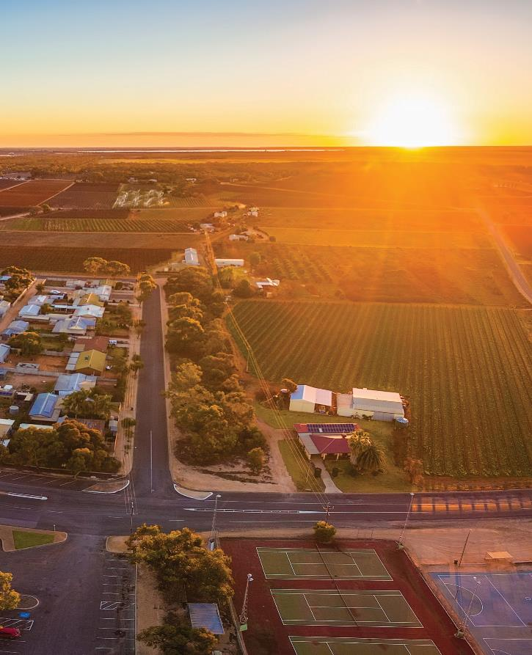

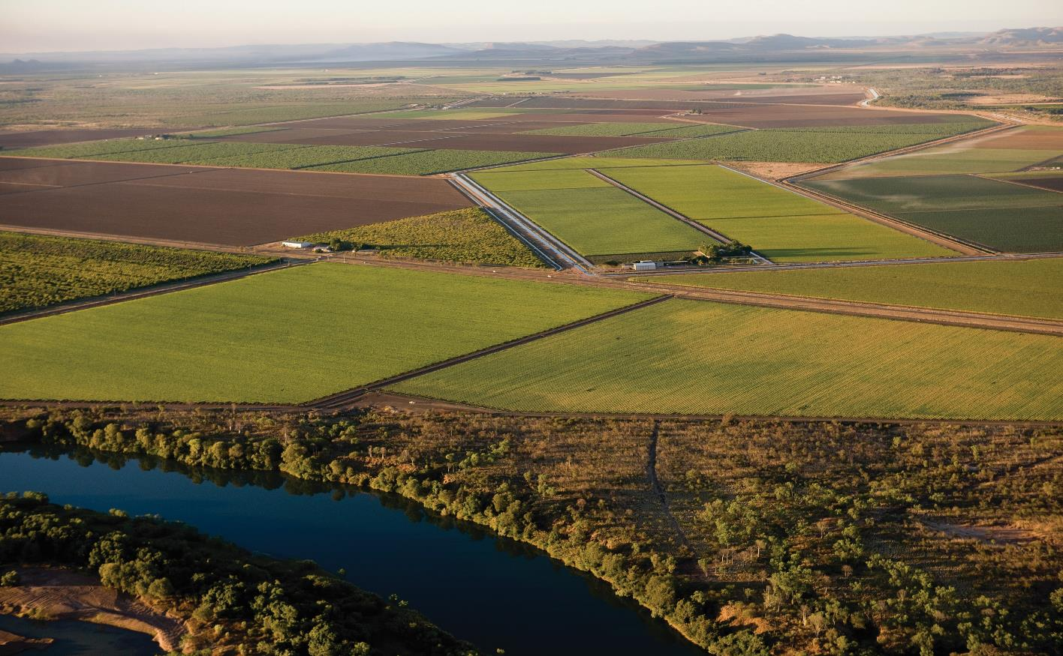

**Conclusion:**

Looking towards a water-secure future

## The NWGA Science Program provides a collaborative, national approach to water science that ensures research outcomes directly inform water resource development and water infrastructure decisions. Research under the program will continue to provide sound science to secure water for our future.



**Being part of the NWGA Science Program has enabled us to work on and address Australia’s**

**biggest groundwater challenges.**

Andrew Taylor, CSIRO

**The NWGA Science Program provides a direct pathway to impact for our research. It ensures our research is provided to decision-makers**

**to inform real-world change.**

Cuan Petheram, CSIRO Land & Water

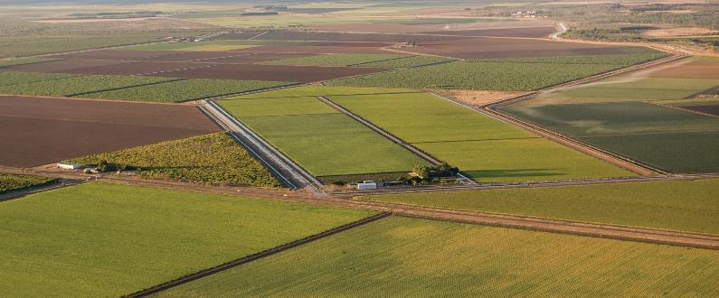

The NWGA Science Program represents a significant investment in water science in Australia. The program provides a national approach to addressing some of the country’s key water security challenges. It brings together Australia’s governments and research organisations

to conduct nationally important research and explore new opportunities and technologies to improve the

sustainability and resilience of Australia’s water resources.

The Science Program provides a direct path to impact for program researchers. This ensures researchers are connected to stakeholders and research findings and outputs are placed into the hands of Australia’s water infrastructure decision-makers. Ongoing

research under the program will be vital in progressing knowledge on how to sustainably build and maintain water security under a changing climate.

Collaborative science to support water decisions

Through its collaborative, evidence-based, responsible investment in science, the NWGA Science Program identifies and progresses opportunities to sustainably develop Australia’s water resources and increase water security while protecting the environment.

Collaborative and partnership approaches to applied science programs like this typically generate returns many times greater than the funds invested.

Progress and opportunities for the

**NWGA Science Program**

Since its inception in 2019, the NWGA Science Program has delivered high-quality scientific information and data to support water infrastructure investment decisions and investigate and progress technologies to provide additional water or improve water security.

Over the coming years, NWGA Science Program projects will deliver a wealth of information and data to inform investments and improve water security. Exciting options for future projects that align with the 2022 National Water Grid Investment Framework include research to:

* continue to progress technologies and opportunities, including managed aquifer recharge to increase water security, using brackish groundwater resources, and increasing use of treated wastewater
* address knowledge gaps relating to water security for regional communities across Australia
* focus on First Nations community water supplies. For example, projects could advance technologies for water purification in remote locations, develop decision-support and planning tools for self-supplied communities, and assess the quality, quantity and possible uses for community groundwater resources.

The suite of collaborative and high-quality research projects conducted under the NWGA Science Program will ensure that sound science is available to secure water for our future.

#### NWGA Science Program project descriptions

**Table 1:** Projects funded by the NWGA Science Program, with brief descriptions. NWGA funding represents the Australian Government contribution, exclusive of GST. Projects may have additional funding or in-kind contributions from research partners. Project status as of end December 2022.

|  |  |  |  |
| --- | --- | --- | --- |
| Research project  (research partner) | NWGA  funding | Status | Description |
| Rapid appraisal of Managed Aquifer Recharge opportunities for agriculture (CSIRO) | **National** | $165,165 | Complete | A national appraisal of irrigation areas that could benefit from managed aquifer recharge to increase water security, augment existing dams and facilitate conjunctive use of surface and groundwater resources. |
| Review of low-cost desalination opportunities for agriculture in Australia nationally (CSIRO) | **National** | $190,000 | Complete | A national appraisal of the viability and feasibility of using desalination technologies to support Australian agriculture. |
| Rapid appraisal of new water infrastructure opportunities nationally (CSIRO) | **National** | $252,213 | Complete | A national appraisal of groundwater systems nationally, and surface water systems in Northern Australia, to identify prospective regions or sites where water infrastructure could be developed to support new or expanded agriculture. |
| Contemporary technical, feasibility and economic viability of the Bradfield Scheme (CSIRO) | **National** | $1,154,900 | Complete | A detailed analysis of the technical feasibility and economic viability of the original Bradfield Scheme, and modern variants, in northern Queensland. |
| Rapid desktop stocktake and appraisal of new and emerging water technologies (RM Consulting Group) | **National** | $65,520 | Complete | A rapid stocktake and appraisal of emerging opportunities  or new technologies, including a gap analysis, to inform future NWGA Science Program investment. |
| NWGA Metrics and Targets (Aither) | **National** | $65,682 | Complete | Developed specific and measurable targets and corresponding metrics for NWGA objectives and outcomes, including identifying appropriate and robust data sources. |
| Investigation of opportunities for and barriers to wastewater reuse (GHD) | **National** | $359,091 | Complete | A national rapid appraisal of prospective regions, locations or sites where further investigation may be warranted  on the reuse of treated wastewater for agriculture. |
| Future hydroclimatic systems impact assessment – national overview  and regional studies (Bureau of Meteorology) | **National** | $775,000 | Complete | An assessment of potential future climate change impacts on water resources nationally and in selected catchments, using global and regional scale information. |
| The risk of salinity due to irrigation developments in the Western Davenport Basin, Northern Territory (Flinders University) | **NT** | $84,000 | Complete | An assessment of the salinity risk from irrigated agriculture over the Central Plains Aquifer/Western Davenport Region of the Northern Territory. |
| Strategic assessment of sustainable agricultural development potential for Mitchell, Flinders and Gilbert Catchments (Qld Government) | **QLD** | $175,000 | Complete | An assessment of the sustainable agricultural development potential for Mitchell, Flinders and Gilbert Catchments, including key considerations, knowledge gaps and  next steps. Builds on the previous CSIRO Northern Australia Water Resource Assessment for the region. |
| Feasibility assessment  of opportunities for underground technologies in Queensland to support future agricultural development (Qld Government) | **QLD** | $160,000 | Complete | Research to refine possible opportunities for underground technologies such as subsurface and sand dams to provide water storage for future agricultural development in Queensland. |
| Integrated surface and groundwater assessment on the Roper River catchment in the Northern  Territory (CSIRO) | **NT** | $5,200,000 | Underway | A comprehensive assessment of water availability, existing uses and sustainable extraction limits, water capture and storage options, and commercial viability of irrigated agriculture and other water uses in the Roper River catchment, NT. |

|  |  |  |  |
| --- | --- | --- | --- |
| Research project  (research partner) | NWGA  funding | Status | Description |
| Victoria River Water Resource Assessment (CSIRO) | **NT** | $6,300,000 | Underway | A comprehensive and integrated assessment of the feasibility, economic viability and sustainability of water resource development of the Victoria River catchment, NT. |
| Southern Gulf Catchment Water  Resource Assessment (CSIRO) | **QLD** | $6,800,000 | Underway | A comprehensive and integrated evaluation of the feasibility, economic viability and sustainability of water resource development of the Southern Gulf catchments straddling the NT/QLD border. |
| Brackish groundwater characterisation project: A Western Australian case study (CSIRO) | **National** | $1,790,212 | Underway | Research to identify and characterise brackish groundwater resources in regions of Western Australia, and investigation of factors that affect use of these resources for potential desalination opportunities. |
| Investigation into solutions for addressing managed aquifer recharge clogging (CSIRO) | **National** | $998,543 | Underway | A national review of causes and management of clogging in operating managed aquifer recharge schemes. |
| Western Davenport hydrostratigraphy (Northern Territory Government) | **NT** | $3,150,000 | Underway | Investigations and analysis to better understand the aquifers and geology relevant to movement and recharge of groundwater, to improve surface and groundwater modeling and increase the evidence base for water planning in the Western Davenport Water Allocation Plan area. |
| LiDAR survey and digital elevation model development for key Northern Territory rivers (Northern Territory Government) | **NT** | $850,000 | Underway | Data collection to develop high accuracy digital elevation models and contours over priority surface water extraction areas in the NT, to inform and refine existing allocation models and plans and determine flood risks to key infrastructure assets. |
| Recalibration of Models in High Demand Water Systems (Northern Territory Government) | **NT** | $400,000 | Underway | A desktop study to refine existing groundwater and surface water models for key Northern Territory water resources, to increase the certainty on the amount of water that can be provided for agricultural developments. |
| Upper King River managed aquifer recharge investigations (Northern Territory Government) | **NT** | $2,450,000 | Underway | An investigation to establish a site for managed aquifer recharge in the Upper King River of the Northern Territory, to provide greater water security for the Katherine region. |
| Adelaide River Catchment Water Allocation Plan (Northern Territory Government) | **NT** | $7,100,000 | Underway | Preliminary research to inform surface water harvesting decisions in the Adelaide River catchment, and to inform the Adelaide River Catchment Water Allocation Plan. |
| Catchment yield science (Tasmanian Government) | **TAS** | $400,000 | Underway | An assessment of the impact of climate change on Tasmanian water resources, to update catchment water yields and inform water allocations, use and infrastructure across Tasmania. |
| Water accountability, metering and reporting framework review (Tasmanian Government) | **TAS** | $70,000 | Underway | An analysis of available technology and water use data required to evaluate water resource management in Tasmania, a review of the policy settings for water  use accountability, metering and reporting, and recommendations for change. |
| Groundwater assessment project  (Tasmanian Government) | **TAS** | $750,000 | Underway | A research report and risk assessment tool to understand  risks and opportunities for groundwater use in Tasmania. |

|  |  |  |  |
| --- | --- | --- | --- |
| Research project  (research partner) | NWGA  funding | Status | Description |
| Improving understanding of groundwater sustainability and renewability using isotope hydrochemistry (NSW Government) **NSW** | $187,713 | Underway | An analysis to determine groundwater age (time since recharge) in NSW aquifers using groundwater stable and decaying isotope data and hydrochemistry results. |
| Managed aquifer recharge opportunities for agriculture in NSW (NSW Government) | **NSW** | $140,000 | Underway | A desktop study to advance possible large-scale managed aquifer recharge schemes in potentially suitable areas of NSW. |
| Improving groundwater supply security for agriculture and primary industries through better understanding of groundwater flow in the Great Artesian Basin (NSW Government) | **NSW** | $941,567 | Underway | An assessment to identify groundwater connectivity and flow paths from the recharge areas of the NSW Great Artesian Basin into the deeper buried sections. |
| Managing water quality to enable  future irrigation development in the Kimberley Region  (WA Government) | **WA** | $250,000 | Underway | A review of the current and future risk profile of agrichemicals (pesticides, herbicides, nutrients) in the Keep River Catchment of the Kimberley region for irrigation development. |
| Managed aquifer recharge pilot in Myalup (WA Government) | **WA** | $3,683,400 | Underway | Development of a pilot managed aquifer recharge scheme in Myalup in south-west Western Australia, including the installation and monitoring of 4 infiltration basins to test the design and parameters. |
| Further sustainable expansion of irrigated agriculture along the Northern Adelaide Corridor (SA Government) | **SA** | $1,120,000 | Underway | A research trial to address challenges of increasing agricultural expansion north of Adelaide (Mallala to Balaklava) using groundwater resources. |
| Optimising the agricultural uses of varying water qualities in the Barossa Region (SA Government) | **SA** | $280,000 | Underway | Research to address the challenge of matching water demands in the Barossa Region with volume and quality of available groundwater. |
| Adaptation of the South-Eastern drainage system under a changing climate (SA Government) | **SA** | $1,500,000 | Underway | An assessment of the climate adaptation potential of the drainage system in the Limestone Coast Landscape Region, including its ability to retain and redirect water in the landscape to mitigate risks and build resilience. |

#### REFERENCES

1 Australian Bureau of Agricultural and Resource Economics and Sciences (2020). Trends in the Australian Agricultural Workforce. Accessible via www.agriculture. gov.au/abares/research-topics/labour/ australian-agricultural-workforce-trends

2 Bureau of Meteorology and CSIRO (2022). State of the Climate 2022. [www.](http://www/) bom.gov.au/state-of-the-climate/ australias-changing-climate.shtml

3 Bureau of Meteorology and CSIRO (2022). State of the Climate 2022. [www.](http://www/) bom.gov.au/state-of-the-climate/ australias-changing-climate.shtml

4 Australian Bureau of Statistics (2022). Population. Accessible via www.abs.

gov.au/statistics/people/population

5 Green J & Moggridge B (2021). Australia state of the environment 2021:

inland water. Accessible via https:// soe.dcceew.gov.au/sites/default/ files/2022-07/soe2021-inland-water.pdf

6 Geoscience Australia (2021). What is Groundwater? Accessible via [www.](http://www/) ga.gov.au/scientific-topics/water/ groundwater/basics/what-is-groundwater

7 Bureau of Meteorology (2021). National Water Account 2020. Accessible via [www.](http://www/) bom.gov.au/water/nwa/2020/overview/

8 Bureau of Meteorology (2021). Water in Australia 2019–20. www.bom. gov.au/water/waterinaustralia/files/ Water-in-Australia-2019-20.pdf

9 Geoscience Australia (2021). What is Groundwater? Accessible via [www.](http://www/) ga.gov.au/scientific-topics/water/ groundwater/basics/what-is-groundwater

10 More information on CSIRO water resource assessments, rapid appraisals and the Bradfield Scheme assessment is available at [www.csiro.au/en/](http://www.csiro.au/en/) research/natural-environment/water/ water-resource-assessment

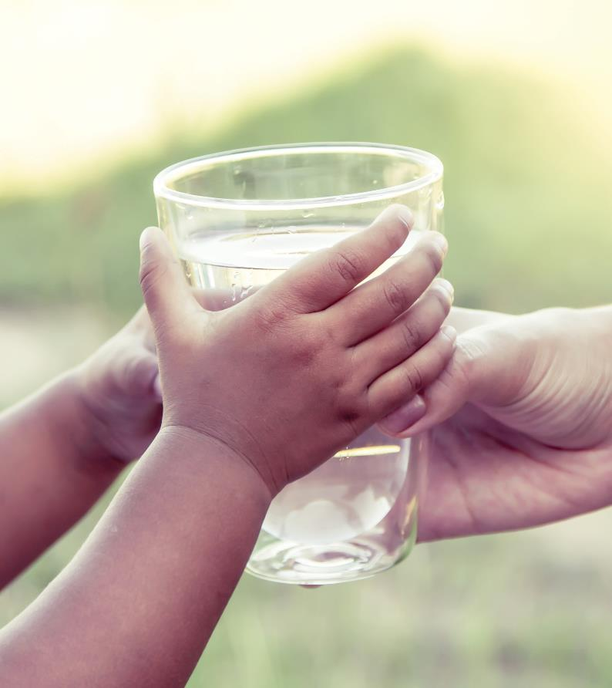



**nationalwatergrid.gov.au**