

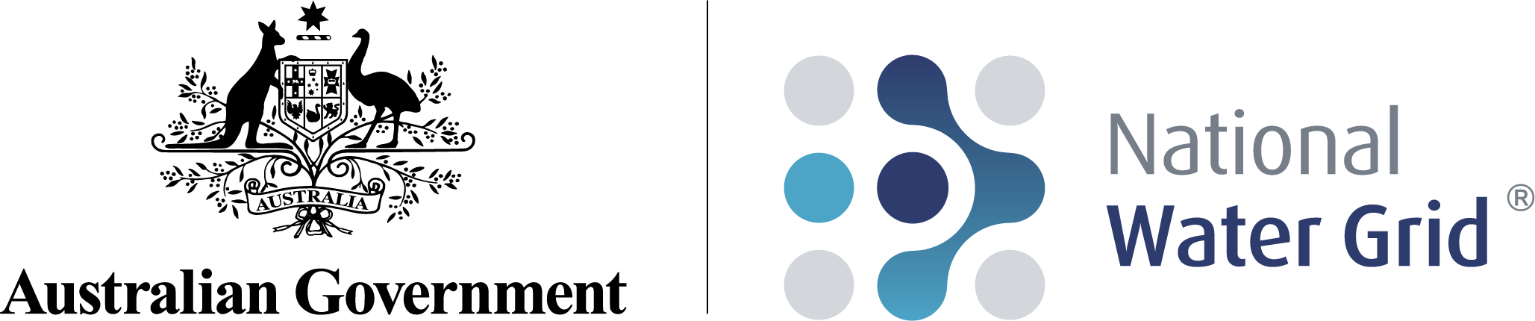

National Water Grid Investment Framework

October 2022

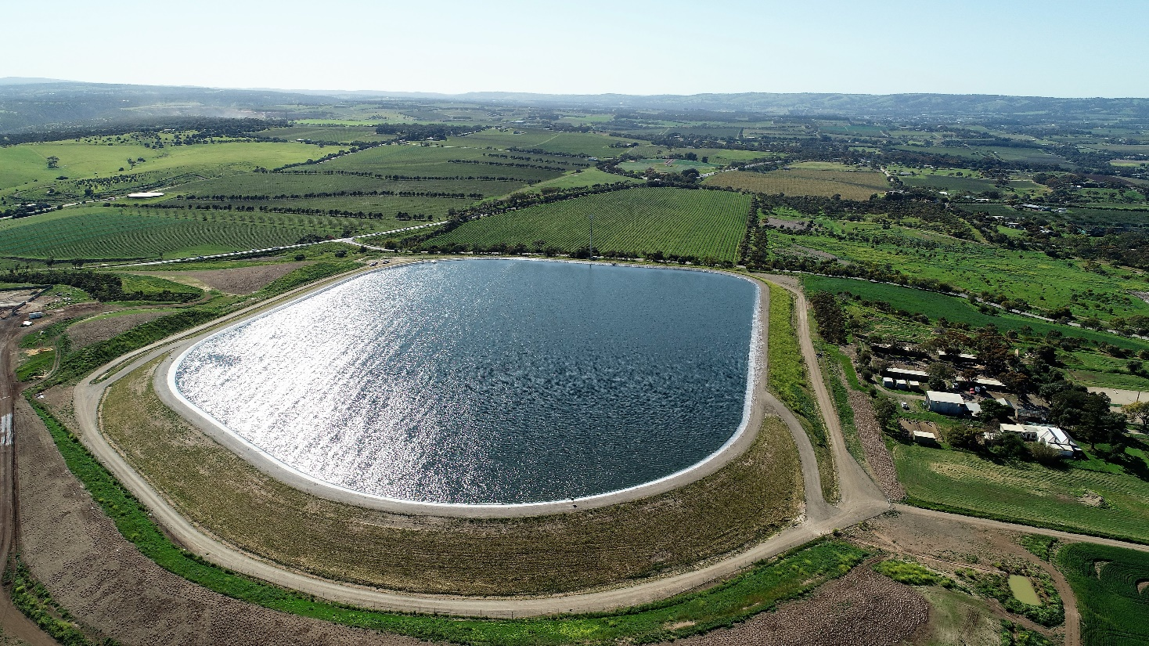

## Acknowledgement of Country

## We acknowledge the Traditional Custodians of Australia and their continuing connection to land and sea, waters, environment and community. We pay our respects to the Traditional Custodians of the lands we live and work on, their culture, and their Elders past and present.

## Copyright

**© Commonwealth of Australia 2022**

**Ownership of intellectual property rights**

Unless otherwise noted, copyright (and any other intellectual property rights, if any) in this publication is owned by the Commonwealth of Australia.

**Creative Commons licence**



**Attribution**

**CC BY**

All material in this publication is licensed under a Creative Commons Attribution 4.0 International Licence, save for content supplied by third parties, logos, any material protected by trademark or otherwise noted in this publication, and the Commonwealth Coat of Arms.

Creative Commons Attribution 4.0 International Licence is a standard form licence agreement that allows you to copy, distribute, transmit and adapt this publication provided you attribute the work. A summary of the licence terms is available from <https://creativecommons.org/licenses/by/4.0/>

The full licence terms are available from <https://creativecommons.org/licenses/by/4.0/legalcode>

Content contained herein should be attributed as *National Water Grid Investment Framework, Australian Government Department of Climate Change, Energy, the Environment and Water*.

**ISBN:** 978-0-6456423-0-8

## Disclaimer

The Australian Government as represented by the Department of Climate Change, Energy, the Environment and Water has exercised due care and skill in the preparation and compilation of the information and data in this publication. Notwithstanding, the Commonwealth of Australia, its officers, employees, or agents disclaim any liability, including liability for negligence, loss howsoever caused, damage, injury, expense or cost incurred by any person as a result of accessing, using or relying upon any of the information or data in this publication to the maximum extent permitted by law.

*Cover photo: McLaren Vale Treated Water Storage project.*

Table of Contents

Investment Framework at a Glance 4

National Water Grid Investment Framework 5

Overview 5

Strategic Objectives 6

Role 6

Investment Principles 7

Implementation 7

Investment Decisions 8

Project Identification and Development 10

Options Analysis 10

Proposal Development 11

Non-infrastructure solutions 11

Project Selection 12

Eligibility Criteria 12

Project Proposal Assessment 13

Funding and Finance 14

Amount and type of funding or finance 14

Requirements on state and territory governments 15

Delivery and Evaluation 16

Monitoring and progress reporting 16

Evaluation 16

# Investment Framework at a Glance

**Strategic Objectives (page 5)**

**Investment Principles (page 6)**

**Eligibility Criteria (page 11)**

# National Water Grid Investment Framework

The National Water Grid Investment Framework outlines the processes for the Australian Government to make well‑informed investments in nationally significant water infrastructure.

## Overview

Access to a safe and reliable water supply is essential for supporting Australian communities and our economy. The Australian Government is committed to working with the state and territory governments to improve water security for all Australians, particularly for those in our regions. The National Water Grid Fund is the Australian Government’s infrastructure investment program to improve water access and security.

Consistent and long-term planning is essential to ensure that investments are economically viable and respond to future challenges such as climate change, population growth and increasing agricultural demand. Investment in water infrastructure must also be ecologically sustainable by considering and taking suitable steps to protect Australia’s natural environment.

Water has an important role in the cultural, social and spiritual identity of First Nations people who have a long history of stewardship of Australia’s water systems. Traditional knowledge and practices can improve water management outcomes and close consultation with First Nations people is critical to informed decision-making that is responsive to cultural heritage. Early consultation will also enable aspirations and opportunities for First Nations peoples to be considered during the project development phase.

Through the National Water Grid Fund, the Australian Government provides funding to state and territory governments to deliver water infrastructure projects. Investment in water infrastructure through the National Water Grid Fund is one part of the Australian Government’s water policy agenda. Investment under the National Water Grid Fund must be aligned to this broader water policy agenda, including the National Water Initiative, and should contribute to other Australian Government priorities where practicable. Investment must also be consistent with Australia’s international obligations.

Infrastructure will not always be the best solution for managing Australia’s scarce water resources. A critical component of well-informed decision-making is that all options, including non-infrastructure solutions, are suitably considered through the project development stage. Demonstration of prior consideration of non-infrastructure options will inform the Australian Government’s assessment of project proposals.

State and territory governments are responsible for the regulation, planning, management and allocation of water resources, including water infrastructure development and maintenance. Close collaboration between the Australian Government and state and territory governments is central to Australian Government investment. Water infrastructure investment must consider and align with the relevant legislative and statutory frameworks relating to water.

The National Water Grid Authority (the Authority) was established to oversee the National Water Grid Fund and provide advice to the Australian Government on national water infrastructure investment decisions. The Investment Framework sets out:

* How the Authority will work in partnership with state and territory governments;
* The strategic objectives, eligibility criteria and principles for investment; and
* The role science has to play in identifying opportunities and evaluating options (noting that there is a separate Science Strategy).

## Strategic Objectives

The Australian Government is committed to working with the state and territory governments to identify, plan and deliver nationally important water infrastructure that increases our nation’s water security, reliability and sustainability. Under the Framework, the Australian Government will identify and invest in projects that address the following strategic objectives:

1. **Provide safe and reliable water for regional and remote communities** – increasing water access, quality and security to better meet essential town water needs in regional and remote Australia.
2. **Generate public benefit through responsible investment in water infrastructure for productive use** – improving water access, quality and security for agricultural, primary industry and industrial use to support regional economic growth and development.
3. **Build resilient water infrastructure that is environmentally sustainable and culturally responsive** – strengthening the National Water Grid so that water infrastructure investments will support the protection of our cultural heritage and better meet future challenges from climate change, while managing environmental impacts.

Contributing to other Australian Government priorities

In addition to the strategic objectives set out above, the Australian Government may choose to prioritise investment in projects that contribute to its broader priorities as well as enabling productive outcomes and meeting essential town water needs. This could include projects that contribute to Closing the Gap targets or that involve water recovery for environmental outcomes.

## Role

The Investment Framework and supporting documents (including the Program Administration Manual) detail the Australian Government’s policy and processes for water infrastructure investment (Figure 1). It brings together the Government’s key strategic objectives and links them to decisions on investment across Australia, as well as details how the Authority advises the Australian Government on infrastructure investment decisions at each stage of the program lifecycle (Figure 3). A robust Investment Framework will inform Australian Government investment in water infrastructure projects at all stages of development.

#### Figure 1: National Water Grid Investment Framework

## Investment Principles

The Framework is underpinned by eight guiding principles that all project proposals must meet in order to be assessed as suitable for funding.

Investment Principles

1. Projects should be of demonstrable public benefit and have a national interest element, including through securing the nation's water security, building resilience to climate change, and enabling economic development.

2. There must be strong state or territory government support, including funding contributions and involvement of the private sector and local government where appropriate.

3. The investment should provide the highest net benefit of all options available to increase access to or security of water, taking into account economic, social and environmental impacts.

4. Projects should look to address circumstances which cannot be effectively addressed by private proponents, states or territories or other stakeholders alone.

5. Projects should align with the National Water Initiative principles including appropriate cost recovery, and where full cost recovery is not deemed feasible, any subsidies are fully transparent.

6. Project development must include engagement with the First Nations communities of potentially affected areas, to comprehensively identify and manage impacts on cultural heritage.

7. If providing capital, a consistent, robust analysis of costs and benefits is used and assessment of appropriate funding and financing arrangements is undertaken.

8. Projects should include early Australian Government involvement in project identification and development, including through the Authority’s Science Program and support for business case development.

## Implementation

The Investment Framework is one element of the overall operating environment. The core elements of a collaborative approach to implementing the Framework and delivering water infrastructure are outlined in Figure 2.

#### Figure 2: Investment Framework Operating Environment

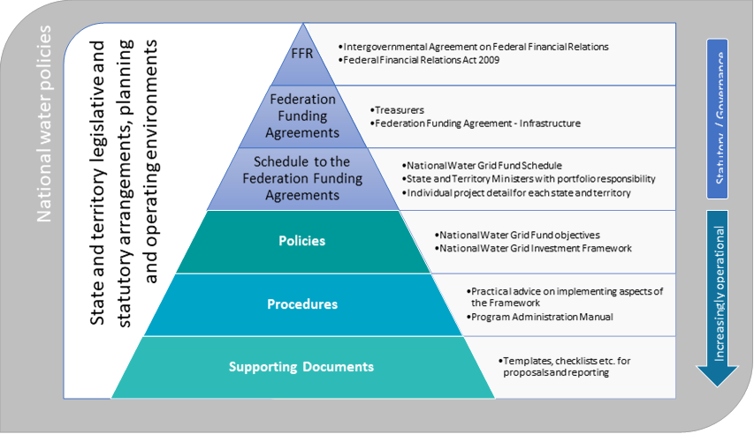

## Investment Decisions

The Investment Framework sets out how the Authority advises the Australian Government on national water infrastructure investment decisions throughout the program lifecycle (Figure 3), including:

* Project Identification and Development – Drawing on the knowledge of states and territories, using sound science, and consulting with impacted stakeholders to identify potential opportunities, problems and solutions.
* Project Selection – Assessment and prioritisation of nationally significant water infrastructure projects for Australian Government investment.
* Funding and Finance – The conditions and arrangements for Australian Government investment in water infrastructure projects.
* Delivery and Evaluation – Monitoring project delivery and analysis of project outcomes.

#### Figure 3: Water Infrastructure Program Lifecycle

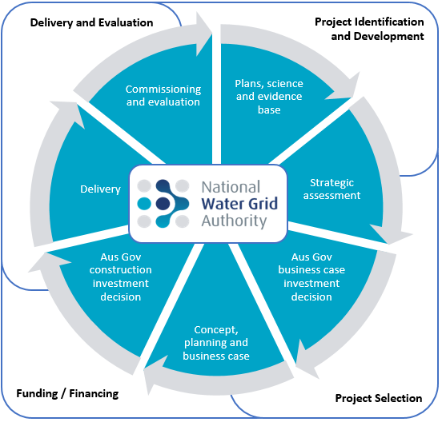

# Project Identification and Development

During the Project Identification and Development stage, the Authority will work with state and territory governments, and Australian Government scientific agencies, to analyse water supply requirements and identify potential opportunities, problems and solutions. In some instances, taking a regional approach to considering investment will ensure that the best infrastructure is delivered in the correct sequence to maximise benefits. This section details the Australian Government’s approach to Project Identification and Development (Figure 4).

#### Figure 4: Project Identification and Development Process

## Options Analysis

To support a well-informed and long-term approach to investment, the Australian Government will have early involvement in project identification and development. In consultation with state and territory governments, the Authority will look to identify where water supplies are not keeping up with the demand of water users, are under threat from climate change and where opportunities exist to capture new water resources or better utilise existing resources.

In practice, Australian Government involvement can include commissioning scientific analysis, contributing to regional strategic planning, and investing in business cases that adequately address all possible solutions. State and territory governments are encouraged to bring forward priority projects that improve water outcomes for Australians and ensure the long-term viability of our communities and economy in the context of climate change.

Where a potential water infrastructure project is identified, the Authority will consult with the relevant jurisdiction and Australian Government agencies as appropriate to explore:

* Policy consistency – Whether the water infrastructure project proposal aligns with the Investment Framework and is consistent with whole-of-government national water reform commitments (such as the National Water Initiative and the Basin Plan), Commonwealth and state and territory legislative and statutory water frameworks, and Australia's international obligations.
* Social, economic, cultural and environmental impacts – How changes to the water system might impact communities, First Nations water use and access to culturally significant sites, and the environment.
* Economic analysis – Whether Australian Government investment is warranted based on consideration of expected costs and benefits.
* Benefits realisation – What benefits will be realised, who will enjoy them and how they will be measured. Such as how a project supports the increased water use sustainably, addresses the impacts of climate change, supports resilience to natural disasters, improves environmental and First Nations outcomes, connects water resources and users, delivers jobs and economic growth for Australia, and improves standards of living. Will identify how beneficiaries will help contribute to the cost of the proposed investment.
* Suitability – Whether the proposal delivers the highest net benefit solution that can be delivered. Projects should address circumstances which cannot be efficiently addressed by private proponents, states and territories or other stakeholders alone.
* Alternative solutions – What alternative solutions, including non-infrastructure solutions, have been explored, and the costs and benefits of those alternative solutions.

## Proposal Development

State and territory governments seeking Australian Government funding will submit a proposal for consideration by the Australian Government. Guidance material and templates for water infrastructure project submissions has been developed and made available to state and territory governments.

The Australian Government may make funding available to state and territory governments to undertake business case development and other analysis that contributes to the evidence base for national water infrastructure investment. Namely, funding may be provided for:

* Environmental, geological, hydrological and other relevant scientific and technical studies that progress the development of specific projects.
* Cost estimations and cost benefit analysis of infrastructure proposals.
* Technical design and engineering appraisals.
* Risk and options analysis.
* Stakeholder consultation.
* Other work required for the project development process.

Funding for business case development cannot be used for activities that have already taken place, capital expenditure, or business as usual operational and administrative functions.

## Non-infrastructure solutions

The National Water Grid Fund provides for Australian Government investment in water infrastructure. In this regard, the Authority will advise the Australian Government on water infrastructure investment decisions to address identified water supply opportunities or problems, noting that infrastructure investment will not always be the best solution.

As part of the Project Identification stage, the Authority expects that state and territory governments will have regard to alternative solutions for water supply improvements, such as regulatory or planning changes, financial assistance, and/or public information. The Authority will work with state and territory governments as needed, including consulting with other Australian Government agencies where required, in order to ensure appropriate consideration has been given to non-infrastructure solutions.

# Project Selection

During the Project Selection stage, the Australian Government will assess the merits of national water infrastructure proposals and recommend projects for Australian Government investment. This section details the Australian Government’s proposed approach to project selection (Figure 5).

The Authority, in consultation with other relevant agencies as appropriate, will assess proposals prior to advising the Australian Government on investment recommendations. In some circumstances, the Australian Government may make upfront investment commitments, contingent on completion of an acceptable business case and submission of a proposal.

#### Figure 5: Project Selection Process

## Eligibility Criteria

To be eligible for Australian Government funding under the Investment Framework, projects must meet all of the following criteria:

* New capital investment in infrastructure that increases the security, quality and/or availability of water for regional and remote communities, and/or productive use.
* Demonstrable public benefit with a national interest element and demonstrated engagement with affected stakeholders (including First Nations people).
* Brought forward with strong support by a state or territory government (including securing funding contributions) and is dependent on a Commonwealth contribution.

A project may consist of a number of smaller regional projects such as piping and delivery schemes that connect water sources together, or a single project such as a large dam or weir, or a new pipeline or water recycling scheme. Consideration may also be given to projects that undertake regional pilots to assess the merits of specific water infrastructure.

In line with the eligibility criteria and investment principles, some types of projects are considered out of scope for Australian Government investment under the National Water Grid Fund. Urban water infrastructure for the sole benefit of residents in major cities is ineligible for funding, as these costs should be borne by utilities and rate payers. Waste and stormwater projects are ineligible for funding, except to the extent they include a productive economic element such as recycled water schemes. Projects for routine maintenance or refurbishment without betterment are also considered out of scope. Significant works required on existing nationally important water infrastructure, such as major safety upgrades, may be considered for funding at the discretion of the Australian Government.

Projects that supply water for the exclusive use of a single entity or that primarily benefit one major customer are also ineligible for funding. Australian Government financial assistance to individuals and businesses (for example, for on-farm irrigation upgrades) is administered under other government programs.

It is noted that an eligible project may deliver wider benefits and the Australian Government may prioritise projects that contribute to broader Government priorities. However, projects that exclusively address these other priorities, such as disaster resilience or environmental water recovery, are not eligible for National Water Grid funding given they are addressed through other Australian Government programs.

The Australian Government may, at its sole discretion, create additional funding pathways or sub-programs within the National Water Grid Fund to address more targeted policy outcomes. In creating these funding pathways or sub-programs the Australian Government may set additional parameters or eligibility criteria, which will be communicated to state and territory governments and made publicly available.

## Project Proposal Assessment

The Authority, in consultation with other relevant agencies as appropriate, will assess the merits of proposals submitted by state and territory governments against the Investment Framework and in the context of the Australian Government’s broader objectives for investment in water infrastructure.

A project proposal must meet all eligibility criteria and be aligned to the eight investment principles. Eligible construction proposals must also demonstrate that all options have been considered, including non‑infrastructure solutions, and be supported by a robust business case.

Project proposal assessment will include consideration of the strategic fit, impact and deliverability of a project with regard to elements such as:

* Completed feasibility and business case work.
* Independent studies and assessments.
* Project location and local constraints.
* The economic, social, cultural and environmental costs and benefits of the project.
* Benefits realisation planning.
* Proposed funding co-contributions.
* Whether alternative options have been explored.
* Wider benefits to other Australian Government priorities.

The Authority will provide advice to the Australian Government on project selection decisions based on this assessment. When the Australian Government selects a project for investment, the investment type, amount and conditions will be determined in the Funding and Finance stage.

The Authority will provide feedback, where possible, when a project is not successful in receiving Australian Government funding.

# Funding and Finance

During the Funding and Finance stage, the Authority will advise the Australian Government on the amount of funding to be offered for National Water Grid projects, and any related investment conditions. The Authority may also seek advice from other Australian Government agencies in making its recommendations. This section details the Australian Government’s proposed approach to funding and financing (Figure 6).

#### Figure 6: Funding and Finance Process

## Amount and type of funding or finance

Australian Government grant funding from all sources is capped at 50 per cent of the capital costs for delivery of a National Water Grid construction project. For clarity, this funding cap does not preclude other sources of finance being sought from the Australian Government for the remaining capital costs of a project (such as concessional loans or equity vehicles). The Australian Government may, at its sole discretion, offer more than 50 per cent funding for an eligible project where the Australian Government deems the project to be transformational in nature or where a specific policy need has been identified.

While a co-contribution from state and territory governments will be sought in all instances, the Australian Government may provide up to 100 per cent of funds for elements of project development, such as the completion of business cases.

The National Water Grid Fund provides grant funding to state and territory governments only. The Australian Government does not recover these contributions. Other funding and finance may be offered through alternative Australian Government agencies and programs. The total combined proposed funding and financing sources will be taken into account as part of the Authority’s assessment of a proposal.

Proposed projects seeking more than $100 million in Australian Government funding will need to outline the process for considering innovative financing methods (for example, the capacity and appetite of the market to be able to deliver and support the proposal, opportunities for private sector contributions) having regard for the *Commonwealth Investment Framework*.

Projects seeking more than $250 million in Australian Government funding are required to be assessed by Infrastructure Australia.

## Requirements on state and territory governments

The Australian Government will invest in water infrastructure projects conditional on the state or territory government:

* Confirming that any required co‑funding for a project has been secured.
* Confirming it, or the asset operator, will meet the ongoing costs for the life of the asset (noting that revenue generated through operations can be used to cover costs).
* Supplying information about water resources, sharing, usage and access with the Authority.
* Demonstrating that potentially impacted First Nations communities have been consulted in development of a project proposal (including proposals for business case funding).
* Working with the Authority to evaluate the project’s outcomes.
* Abiding by any other conditions required by the Australian Government.

The Authority’s *Indigenous Employment and Supplier-Use Water Infrastructure Framework* applies to all construction projects seeking new funding and may require the completion of an Indigenous Participation Plan.

The key terms and conditions of the Australian Government’s funding for water infrastructure projects are set out in the relevant Federation Funding Agreement and Schedules, as in force from time to time. These agreements are available at [www.federalfinancialrelations.gov.au](http://www.federalfinancialrelations.gov.au).

# Delivery and Evaluation

The Australian Government generally has no direct role in the delivery of water infrastructure projects. Under the Federation Funding Agreements arrangement for project delivery, the relevant state or territory government will be responsible for all procurement and project management arrangements. The jurisdiction will also determine operational and access arrangements for the infrastructure asset, consistent with the principles of the National Water Initiative. This section details the Australian Government’s proposed approach to Delivery and Evaluation (Figure 7).

#### Figure 7: Delivery and Evaluation Process

## Monitoring and progress reporting

The Authority will work with state and territory governments to confirm project delivery progress and provide progress payments upon the completion of agreed milestones consistent with the Federation Funding Agreements processes and reporting requirements.

## Evaluation

The Authority will work with state and territory governments to evaluate project outcomes post‑completion, and to identify and apply lessons learnt. Project evaluation will be led by the relevant state or territory government. An initial evaluation will be undertaken through the submission of a Project Completion Report upon completion of a construction project. Subsequent project evaluation should occur once sufficient information is available to assess the project’s outcomes against stated objectives (i.e. water supply volume and distribution outcomes) which may be several years after project completion. The evaluation will consider whether the delivered project:

* Is consistent with the project proposal (in terms of timeliness, budget and project specifications).
* Met the Framework strategic objectives and intended project outcomes.
* Is providing the expected benefits (through a benefits assessment).
* Had any additional outcomes, positive or negative.

Agreement to conduct an evaluation, in consultation with the Authority, will be an Australian Government investment condition. The Authority will draw on evaluation findings in making future water infrastructure investment decisions.

The Authority will, in consultation with state and territory governments, publish summaries of all completed projects to share outcomes delivered through Australian Government investment.